|  |
| --- |
|  |
|  |
| Project FUSION  FUSION Interim Trial Learnings Report #1  SP Energy Networks |
| **Report No.: 21-10130767-0820, Rev. 0.1**  **Date of first issue:** 2021-08-20  Date of this revision: 2021-09-23 |
|  |

|  |  |  |
| --- | --- | --- |
| Title page. 1) Displayed on front cover. 2) Displayed in footer on Page 1 onwards. | |  |
| Project name:1 | Project FUSION | Energy Systems  DNV GL Limited  30 Stamford Street London SE1 9LQ  United Kingdom  Tel: +31 26 356 9111  Registered Arnhem 09006404 |
| Report title:1 | FUSION Interim Trial Learnings Report #1 |
| Customer:1 | SP Energy Networks, 320 St Vincent St, Glasgow G2 5AD |
| Customer contact: | Michael Green |
| Date of issue:1 | 20-08-2021 |
| Project No.: | 10130767 |
| Organisation unit: | Energy Markets & Technology |
| Report No.:1,2 | 21-10130767-0820, Rev.1,2 0.1 |
|  | | |

|  |  |  |  |  |  |
| --- | --- | --- | --- | --- | --- |
| Prepared by: | Prepared by: |  |  | Verified by: | Approved |
|  |  |  |  |  |  |
| Aurora Sáez Armenteros – Energy Systems Consultant | Angeliki Gkogka – Energy Systems  Senior  Consultant |  |  | Hans de Heer – Enery Systems Business Manager  Demand Side Flexibility | Rafiek Versmissen –  Head of Energy Strategy Advisory |

|  |  |
| --- | --- |
| Copyright © DNV 2021. All rights reserved. Unless otherwise agreed in writing: (i) This publication or parts thereof may not be copied, reproduced or transmitted in any form, or by any means, whether digitally or otherwise; (ii) The content of this publication shall be kept confidential by the customer; (iii) No third party may rely on its contents; and (iv) DNV undertakes no duty of care toward any third party. Reference to part of this publication which may lead to misinterpretation is prohibited. | |
|  |  |
| DNV Distribution: | Keywords: |
| Open | [Keywords] |
| Internal use only |
| Commercial in confidence  Confidential* |
| Secret |
| *Specify distribution: -- |
|  | |

|  |  |  |  |  |  |
| --- | --- | --- | --- | --- | --- |
| Rev. No. | Date | Reason for Issue | Prepared by | Verified by | Approved by |
| 0 | 2021-08-20 | First issue | Angeliki Gkogka, Aurora Sáez Armenteros | Hans de Heer | Rafiek Versmissen |
| 0.1 | 2021-09-22 | Second issue, following feedback and questions from SP ENERGY NETWORKS | Angeliki Gkogka, Aurora Sáez Armenteros |  | Hans de Heer |

Table of contents

EXECUTIVE SUMMARY 1

1 Introduction 5

1.1 Overview to Project FUSION 5

1.2 USEF Overview 5

1.3 Background to this document 6

1.4 Purpose of this document 6

2 Trial Facts 7

2.1 Trial objectives 7

2.2 Roles and responsibilities 11

2.3 Flexibility services procured in trial 1 12

2.4 Flexibility providers and flexible assets 14

3 Trial progress to date 15

3.1 Procurement and Contracting FFP 16

3.2 Procurement and Contracting Flexibility 16

3.2.1 Flexibility procurement process 16

3.2.2 Evaluation methodology 17

3.2.3 Flexibility service agreement 18

3.3 FUSION trial architecture and Implementation 18

3.3.1 UFTP Implementation 18

3.3.2 FUSION simulators 22

3.4 Testing processes 23

3.4.1 Factory Acceptance Test (FAT) 24

3.4.2 Site Acceptance Test (SAT) 24

3.4.3 Aggregator USEF compliance test 25

3.4.4 User Acceptance Test (UAT) 26

3.4.5 End-to-end integration test 27

3.4.6 Commissioning test 28

3.5 Operation 29

3.5.1 Use cases and test cases 29

3.5.2 Trial simulation schedule 33

3.5.3 Validation and settlement 36

4 Learnings from the implementation 37

4.1 Learnings from Aggregators 37

4.1.1 Orange Power Learnings 37

4.1.2 Engie/Gridimp 38

4.2 Learnings from OpusOne 39

4.3 Learnings from FUSION partners 40

4.3.1 Optional UFTP features 40

5 Evaluation of the learning objectives 41

5.1 D-Programmes 41

5.2 Free Bids 41

5.3 Sub-metering arrangements 43

5.4 Baseline design – nomination baseline 44

5.5 Market Coordination Mechanism (MCM) 44

5.6 USEF Flexibility Trading Protocol (UFTP) 45

6 Next steps 47

6.1 Next steps for the phase 1 trial 47

6.2 Phase 2 trial 47

6.2.1 Alleviating real congestion in East Fife 47

6.2.2 Learnings objectives for phase 2 47

6.2.3 Phase 2 trial set-up 48

6.2.4 Stakeholder engagement 49

# EXECUTIVE SUMMARY

DNV has prepared this document on behalf of SP ENERGY NETWORKS to document the set-up, progress, the implementation and the progress of phase 1 of the FUSION trial which commenced on 09th Sep 2021, as well as learnings to date and next steps. This document provides an overview of:

* Background of the trial, key facts of the trial, its **learnings objectives** and the involved **USEF roles** and responsibilities
* Flexibility providers and **flexibility assets** that take part in phase 1
* The **contracting processes** of the FUSION Flexibility Platform (FFP) and the flexibility requirements
* The **FUSION trial architecture** and its implementation
* The **testing processes** that were performed ahead of the trial
* **Progress update** on the operation of the trial
* **Learnings** from the implementation to date
* **Next steps** for phase 1 and 2 of the trial, which is planned to commence in April 2022.

Phase 1 of the FUSION trial is now fully operational, and flexibility is being dispatched in both, St. Andrews and Leuchars, areas. Since the grid is not constraint, the events are being simulated to create for instance, faults, overloading, etc. Project FUSION partners agreed on a **set of objectives** that will be addressed during phase 1:

1. Evaluate the **feasibility, costs** and **benefits** of implementing a common flexibility market framework based on the open **USEF model** to manage local distribution network constraints and support wider national network balancing requirements.
2. Investigate a range of **commercial mechanisms** to **encourage** flexibility from energy consumers’ use of **multi-vector electrical** applications in satisfying overall energy use.
3. Understand how **FUSION and FP** meet the requirements of SP Energy Networks and facilitate their DSO transition. Consider which FUSION elements will contribute to SP Energy Networks’ development of skills and competences.
4. Understand how and where **D-programmes** can be integrated in grid operations.
5. Explore the benefit of **free bids** in the context of DSO flexibility trading.
6. Investigate the role of **sub-metering** in DSO services is largely unexplored.
7. Test the performance of **nomination baselines** in DSO congestion management.
8. Use the USEF market coordination mechanism **(MCM)** to set the interactions between DSO and AGR for flexibility trading, and explore the fit and the **added value for GB** context.
9. Test the use of USEF Flexibility Trading Protocol for DSO congestion management in **GB**.

To date, project FUSION generated learnings from the trial implementation. The implementation involved:

* Procurement and contraction of the FUSION Flexibility **Platform**
* Procurement and contracting of **flexibility** in the areas of St. Andrews and Leuchars, using the Flexibility Services Agreement (FSA)
* **Implementation of the USEF** on DSO and aggregator’s side
* **Testing** of the FUSION Flexibility Platform and USEF-compliant aggregator’s platforms
* Development of additional tools for testing and for the operation of the trial, for example, the **data preparation tool** and **validation tools**.
* **Design of test cases** to be simulated during phase 1
* **Delivery of a fully operational local flexibility market** in the phase 1 of the trial.

**Learnings from the Implementation**

At the time of writing this report, the trial is in progress. Therefore, learnings reflect learnings from the implementation of the required processes, testing and tools for prior to the trial going live.

The learnings reflect:

* Learnings from the implementation of the UFTP and USEF processes by the Aggregators;
* Learnings from the developments of the FFP from OpusOne; and
* Learnings from FUSION partners

Orange Power has identified the following learnings:

* The trading process of FUSION’s products and USEF’s trading are aligned with existing UK ESO and DSO products in terms of forecasting, metering and settlement.
* Orange Power highlighted the value of standardisation of the DSO procurement and flexibility market trading processes using UFTP or similar standards, as it would also help aggregators to standardise their tools and trading rules so that these align with all the DSO products.
* Orange Power highlighted the benefits of using a testing/ simulator environment.
* Orange Power would recommend the use of UFTP for DSO congestion management in GB and in continental Europe.
* With regard to the required effort to implement UFTP and USEF processes, Orange Power indicated that the largest amount of effort was required for getting familiar with and trained for the DSO energy trading, rather than for implementing the UFTP.
* The main challenges that Orange Power encountered were linked to changes or wrong interpretation of the UFTP document.
* Orange Power recommend to future aggregator/ participant that they start using the DSO stub earlier in the process, so that the coding cycles are delivered in shorter sprints, and then each small code sprint is tested and implemented before moving to the next coding sprint.

Gridimp on behalf of Engie has identified the following learnings:

* Gridimp consider the implementation of the UFTP of medium effort. Compared to other platforms, Gridimp consider the UFTP implementation more complex, on the grounds of the additional functionalities of bidding and settlement.
* With regard to the value of the use of UFTP in GB, Gridimp suggested that the automation of bidding, dispatch and settlement are the key advantages of the UFTP, which will lower costs and increase market participation.
* Gridimp also provided feedback related to the implementation of the UFTP. They mentioned that the specification of UFTP and trial specific documents provided sufficient information, however they suggest that it would be more beneficial if the DNO simulation and the CRO stub were available earlier in the process.
* Similar to Orange Power’s feedback, Gridimp consider the testing process essential and they recommend a test environment when developing the UFTP, such as a shared reference test environment.
* Finally, Gridimp provided the specific recommendations to improve the UFTP.

OpusOne indicated the following learnings from the end-to-end integration testing which will be considered for further improvements to USEF and UFTP prior to phase 2 trial:

* Sending historical Imbalance Settlement Periods (ISPs) as part of an Operate phase FlexOrder does not actually provide much benefits from the operator perspective. As such ordering availability or deficiency for past time frames could be re-designed. This is a requirement based on the UFTP.
* Updated D-Prognoses are intended to capture any rebound effects but these are very hard to capture in such short timeframes and to a granular extent. At present this is not accounted for D-prognosis updates during phase 1 trial.
* The formats of entity addresses for both congestion points and connections are not very user-friendly or easy to identify. A convention that may reference the names of congestion points and connections may be easier to utilize for both aggregators and operators
* At present AGRPortfolioUpdates are completed before AGRPortfolioQuery messages. It may be useful to facilitate the aggregators first getting access to all connections form the portfolio updates.

**Learnings from FUSION partners**

USEF and UFTP consist of a set of mandatory requirements that the AGR and the DSO should implement. In addition, both include a set of optional features such as the inclusion of the rebound effect. Several of these optional features were not implemented for phase 1 due to a lack of explicit requirements towards the Aggregators for these items. As such, it is recommended that the tendering process of phase 2 should include explicit requirements for the implementation of certain optional features (which should be implemented by the participating aggregators), since they will contribute to the trial learning objectives that have been formulated. These features include:

* Rebound effect: The aggregator should specify in the flex offer, in case load (or generation) shifting is applied for delivery, when the rebound is expected to occur (limited to the same day, either before or after the activation).
* Delivery monitoring: The aggregator should ensure that it delivers the contracted flexibility, also if certain assets fail to deliver. In all cases the DSO should be notified if the Aggregator expects any under-delivery.

There are more optional features in UFTP, such as the support for partial activation. These have not been further elaborated here, as the need to test these features have not yet emerged (e.g. from the trial learning objectives).

**Next Steps for project FUSION**

Project FUSION will:

1. evaluate the learnings of phase 1 of the trial, which is ending in March 2022
2. prepare for phase 2, which is commencing on April 2022. Phase 2 of the trial will address real congestion in East-Fife. Project FUSION’s key objectives for phase 2 are to:
   1. Apply the first USEF-complied local flexibility market to alleviate real congestion in East Fife
   2. Generate additional learnings to help standardise the GB DSO flexibility market
3. Continue extended stakeholder engagement in order to ensure sufficient levels of Distributed Energy Resources (DER) and recruit additional residential flexibility for phase 2.

# 1 Introduction

## Overview to Project FUSION

Project FUSION is funded under Ofgem’s 2017 Network Innovation Competition (NIC), to be delivered by SP Energy Networks in partnership with seven project partners: DNV(formerly: DNV GL), Origami Energy, Imperial College London (academic partner), SAC Consulting, The University of St. Andrews, and Fife Council.

Project FUSION represents a key element of SP Energy Network’s transition to becoming a Distribution System Operator, taking a step towards a clean, smart and efficient energy system. As the electricity system changes from a centralised to decentralised model, it enables a smarter and more flexible network to function. Project FUSION is trialling the use of commoditised local demand-side flexibility through a structured and competitive market, based on a universal, standardised market-based framework: the Universal Smart Energy Framework (USEF). USEF provides a standardised framework that defines products, market roles, processes and agreements, as well as specifying data exchange, interfaces and control features. The purpose of USEF is to accelerate the transition to a smart, flexible energy system to maximise benefits for current and future customers.

FUSION will also inform wider policy development around flexibility markets and the DNO-DSO transition through the development and testing of standardised industry specifications, processes, and requirements for transparent information exchange between market participants accessing market-based flexibility services. Ultimately, FUSION will contribute to Distribution Network Operators and all market actors unlocking potential and value of local network flexibility in a competitive and transparent manner. In doing so, FUSION aims to contribute to addressing the energy trilemma by making the energy system more secure, more affordable and more sustainable.

## USEF Overview

The USEF framework aims to facilitate effective coordination across all the different actors involved in the electricity market by providing a common standardised roles model and market design while describing communication requirements and interactions between market roles. USEF turns flexible energy use into a tradeable commodity available for all energy market participants, separated from (but in coordination with) the traditional electricity supply chain, to optimise the use of resources. USEF focuses on explicit demand-side flexibility, in which prosumers are contracted by the aggregator to provide specific flexibility services using Active Demand and Supply (ADS) assets. USEF acknowledges but does not provide detailed considerations for implicit demand-side flexibility or peer-to-peer energy trading.

To facilitate the transition towards a cost-effective and scalable model, the framework provides the essential tools and mechanisms which redefine existing energy market roles, add new roles and specify interactions and communications between them. In addition, the USEF standard ensures that all technologies and projects will be compatible and connectable to the energy system, facilitating project interconnection, hence fostering innovation and accelerating the smart energy transition. By delivering a common standard to build on, USEF connects people, technologies, projects and energy markets in a cost-effective manner. Its market-based mechanism defines the rules required to optimise the whole system, ensuring that energy is produced, delivered and managed at lowest cost for the whole system and effectively for the end-user. The USEF framework provides:

* a standardised common framework designed to be implemented on top of current energy markets such as wholesale, retail and capacity markets.
* A description of the flexibility value chain (FVC) involving new and existing market players and giving a central role to the aggregator in facilitating flexibility transactions.
* A roles model and interaction model to enable the implementation of different business models and interactions between actors
* A market design described by the Market Coordination Mechanism (MCM) which sets out the phases and interaction requirements for flexibility transactions. The MCM provides all stakeholders with equal access to a smart energy system. To this end, it facilitates the delivery of value propositions (i.e. marketable services) to various market parties without imposing limitations on the diversity and customisation of those propositions.
* Detailed communication and markets access requirements taking into considerations privacy and cybersecurity issues.

USEF was initially developed by the USEF Foundation. In 2014, the USEF Foundation was founded to accelerate the establishment of an integrated smart energy market which benefited all stakeholders, from energy companies to consumers. USEF was an early mover, a combined force of parties and professionals with a shared goal. Together they explored new territories to help unlock and structure the future market and, as a result, many elements of USEF can now be found in standardisation and harmonisation policies at both national and European level.

In 2021, 7 years later, the work of the USEF Foundation is therefore considered complete and USEF Foundation has ceased to exist by 1 July. To safeguard the legacy of the USEF foundation, the USEF framework, including the UFTP protocol (recently rebranded to Shapeshifter) will be maintained by the GOPACS organisation. The Shapeshifer protocol has also been adopted by the Linux Energy Foundation, offering a platform for the maintenance and support of the protocol.

## Background to this document

Project FUSION commenced in September 2018. Since then, a number of milestones and activities have been completed, including the **flexibility market evaluation,** the **USEF implementation plan** and **USEF process implementation,** whilst stakeholder engagement and coordination with ENA Open Networks are ongoing over the lifespan of the project. All these activities have informed the set-up and implementation of the physical trials of commoditised flexibility trading based on USEF, which are further described in this document.

## Purpose of this document

DNV has prepared this document on behalf of SP ENERGY NETWORKS to document the set-up, progress, the implementation and the progress of phase 1 of the FUSION trial which commenced on 09th Sep 2021, as well as learnings to date and next steps. This document provides an overview of:

* Background of the trial, key facts of the trial, its learning objectives and the involved USEF roles and responsibilities;
* Flexibility providers and flexibility assets that take part in phase 1;
* The contracting processes of the FUSION Flexibility Platform (FFP) and the flexibility requirements;
* The FUSION trial architecture and its implementation;
* The testing processes that were performed ahead of the trial;
* Progress update on the operation of the trial;
* Implementation learnings to date; and
* Next steps for phases 1 and 2 of the trial, which is planned to commence in April 2022.

# Trial Facts

This section describes the key elements of phase 1 of the FUSION live trial and particularly the learning objectives, the involved roles and responsibility, and details on the flexibility services that are procured in trial 1.

## Trial objectives

Project FUSION partners agreed the trial objectives through a number of workshops. The trial objectives are grouped under 3 categories:

1. Final Submission Proposal (FSP) objectives: These objectives reflect the initial FSP objectives of project FUSION, which were submitted to and approved by Ofgem.
2. SP ENERGY NETWORKS objectives: Alongside FSP objectives, SP ENERGY NETWORKS has set up its own objectives to position them as the leading DSO with regard to flexibility mechanisms and prepare the organisation for the transition from DNO to DSO.
3. USEF Innovative Elements (UIE): Previous work of project FUSION produced the USEF FUSION implementation plan, which described the planned deployment of innovative elements from the USEF framework in the flexibility market trial. In developing the plan and based on stakeholders’ feedback obtained through the USEF consultation, project FUSION partners discussed and agreed which USEF processes and innovative USEF elements should be part of the trial, to offer more value and leanings to the industry. Some of the trial objectives are linked to these USEF Innovative Elements.

Please note that one of the FSP objectives is to implement and deploy the USEF framework in the Fife area, and to assess the cost and benefits of this deployment. Since most of these benefits are provided by the UIE, there is a close link between the FSP objectives and the UIE.

Table 1 summarises the trial objectives and their underlying learning objectives.

Table 1: FUSION trial objectives

|  |  |  |  |  |
| --- | --- | --- | --- | --- |
| ID | Main category | Trial objective Name | Description | Owner |
| 1.1 | **FSP Objective** | FSP Objective - CBA | Evaluate the feasibility, costs and benefits of implementing a common flexibility market framework based on the open USEF model to manage local distribution network constraints and support wider national network balancing requirements. | ICL/ Others |
|  | | **Learning Objective** | 1 Establish impact of USEF model on flexibility CBA drivers: change in available capacity of flexibility |
| 2 Establish impact of USEF model on flexibility CBA drivers: change in availability of flexibility including change in common mode failures |
| 3 Establish impact of USEF model on flexibility CBA drivers: shape of load recovery model, |
| 4 Establish impact of USEF model on flexibility CBA drivers: change in costs for DSO to acquire or activate flexibility |
| 5 Establish impact of USEF model on flexibility CBA drivers: change in absorption of (additional) renewable energy resources) |
| 1.2 | **FSP Objective** | FSP Objective - Commercial Mechanisms | Investigate a range of commercial mechanisms to encourage flexibility from energy consumers’ use of multi-vector electrical applications in satisfying overall energy use. | Origami / others |
|  | | **Learning Objective** | 1 What are the commercial mechanisms available to aggregators to encourage participation? |
| 2 Which commercial proposition offered by the two aggregators in Year 1 of the FUSION Trial attracted the most participants? |
| 3 Do ‘FlexOptions’ contracts and Free Bids provide more incentives for flexibility utilisation by aggregators than BAU processes? Are there opportunities for these processes to be used more effectively? |
| 1.3 | **SP ENERGY NETWORKS Objective** | SP ENERGY NETWORKS Objective – SP ENERGY NETWORKS's Flexibility Platform and Framework | Articulate how FUSION complements SP Energy Networks BaU flexibility activity in meeting their strategic requirements. Consider which FUSION elements will contribute to SP Energy Networks’ development of skills and competences. | SP ENERGY NETWORKS, supported by DNV and Origami |
| 1.4 | **USEF Innovative Element** | USEF Innovative Elements – D programmes | Within USEF, D-programmes have two functions: (i) to inform the DSO ex-ante how flexibility will be deployed (ii) they are the basis for settlement. The second function is addressed under "baseline design". This objective focuses on the first function, where D-programmes can be integrated in grid operations. | DNV |
|  | | **Learning Objective** | 1 Can D-programmes (inc. varying timing) improve the forecasting accuracy for grid components? Would this lead to less flexibility being activated? How much? |
| 2 How should these forecasts be integrated in the forecasting process, e.g. how should sub-metering be handled? |
| 3 Is the current mechanism sufficient, or should it be augmented with other information, e.g. contractual information that could be added to the CRO? |
| 1.5 | **USEF Innovative Element** | USEF Innovative Elements – Free Bids | In current DSO flexibility procurement/deployment, only firm capacity is contracted. This disqualifies certain technologies, that cannot provide this firmness, from participating. DSOs could benefit from the use of free bids, as a wider range of technology could lower utilisation costs. FSPs controlling these technologies could benefit, as they have access to additional markets. | DNV |
|  | | **Learning Objective** | 1 Which assets can participate in DA/ID congestion management that cannot be considered firm capacity? What is their expected (flexible) volume in 2025-2030, compared to current (C&I) volumes? |
| 2 What is the effect on the liquidity / activation prices / DSO costs? |
| 3 How could assets that have no firm commitment to DSO services, participate in ESO services? What would be the positive impact of this kind of value stacking to whole system optimisation and carbon reduction? |
| 4 How can the business case of FSPs operating these types of technologies improve, when they have access to this additional revenue stream? Can we expect that this will lead to more (residential) AGRs participating in DSO products? If so, what is the relative increase, by when? |
| 1.6 | **USEF Innovative Element** | USEF Innovative Elements– Submetering arrangements | The choice either to use MPAN meter data or sub-meter data for service delivery validation and settlement may have a major impact, both on provider side and on DSO side. Where traditionally the electricity market was centred around MPAN metering, arrangement gradually open up to allow sub-metering (e.g. balancing services). The role of sub-metering in DSO services is largely unexplored. | DNV |
|  | | **Learning Objective** | 1 Should the main- or sub-meter be used for settlement from the AGR perspective? |
| 2 Should the main- or sub-meter be used for settlement from the DSO perspective? |
| 3 Which meter data validation is required, when meter data is provided by FSP? |
| 4 Which improvement on baseline accuracy is feasible when applying sub-metering, for which technologies? |
| 5 As a consequence of 4, which technologies can only participate when applying sub-metering? What are the barriers for using MPAN? |
| 1.7 | **USEF Innovative Element** | USEF Innovative Elements – Baseline design/Nomination Baseline | DSO products for congestion management typically use historical baselines as a basis for the validation and settlement of the delivery. A recent ENA study suggests widening up the possibilities for FSPs, by allowing nomination baselines when the default baseline in not sufficiently accurate. Within FUSION, a test can be performed on the performance of these baseline types. | DNV |
|  | | **Learning Objective** | 1 Can a nomination BM provide higher accuracy than historical or MBMA? If so, under which conditions (product, technology, season, etc.) |
| 2 Which processes are needed for this BM type (information exchange, monitoring) |
| 3 How complex is the implementation of these processes? |
| 4 Would this (additional) baseline increase the inclusivity of the CM products? |
| 5 If so, what would be the associated (societal) benefits? |
| 1.8 | **USEF Innovative Element** | USEF Innovative Elements – Market Coordination Mechanism (MCM) | USEF includes a market coordination mechanism (MCM) that describes the interaction between market parties related to (explicit) flexibility throughout different phases; the interaction between DSO and AGR is described by UFTP. | DNV |
|  | | **Learning Objective** | 1 How does USEF MCM fit into DSO day-to-day operations? |
| 2 Understand and record which DSOs BaU teams should be involved in the MCM and their role. |
| 3 How does the MCM compare to the current flexibility operation at SP ENERGY NETWORKS? what are the benefits in terms of efficiency and reliability? Does less flexibility need to be contracted/ activated? How much? |
| 4 Who is responsible for re-dispatching? |
| 5 Which additional information exchange with ESO is needed? |
| 5 Does the MCM provides additional value on dealing with rebound effects?  Does the DSO need to activate less flexibility, if so, how much? |
| 6 Are the ENA-defined services fit-for-purpose? |
| 7 Will all different services be used, and under which circumstances? |
| 8 Will services be used in parallel? |
| 9 If so, can assets participate in different services at the same time? |
| 10 Should FSPs and/or assets be contracted for specific services, or should they be contracted as flexibility to be used in different services, at the DSO’s discretion? |
| 11 What is the impact of the aspects above on the standardised contract (FSA) |
| 12 How often can the DSO drop the flex reservation, what is the value to the AGR (by bringing it to other markets?) |
| 13 How are assets selected in the BaU situation, what are the expected saving when using a merit order approach? |
| 14 Do portfolio bids increase the reliability, efficiency or value stacking options compared to asset bids? How much? |
| 15 Intraday updates: To what extent are D-prognoses updated intraday, before the flexibility has been ordered? To what extent are failures to deliver the ordered flexibility notified ahead of the activation? Does this trigger the DSO to activate more flexibility? |
| 1.9 | **USEF Innovative Element** | USEF Innovative Elements – UFTP | Interaction between the DSO and Aggregator has been formalised through the USEF Flexibility Trading Protocol (UFTP). | DNV |
|  | | **.** | 1 Is UFTP fit-for-purpose for the GB market? |
| 2 Suitability of UFTP relative to ENA products |
| 3 UFTP integration/ implementation costs. |
| 4 Which cost savings can be achieved when all DSOs apply the same flex trading protocol? ON GB level and on EUR level? |
| 5 To what extend would the absence of a standardized protocol form a barrier to participate, both for firm and non-firm capacity? |

In addition to the trial objectives, one of the Project FUSION partners, ICL, has developed the trial hypotheses which support in conducting the Cost Benefit Analysis (CBA) and will receive inputs from several other learning objectives. The hypotheses being tested are:

1. Increased participation of market players in DSO products;
2. Higher amount of capacity participating in DSO products;
3. Increased availability of delivery (reliability);
4. Improved performance in load recovery (leading to lower costs for DSO);
5. Lower costs for DSOs to acquire or activate flexibility; and
6. Improved absorption of (additional) renewable energy resources.

## Roles and responsibilities

Project FUSION partners agreed the FUSION USEF Implementation Plan, covering the flexibility services and the USEF roles that the trial will seek to test and are relevant to the implementation of the USEF based market. Table 2 sets out the roles to be included in the trial and the market party that will perform them.

Table 2: USEF roles in the FUSION trial

|  |  |  |  |
| --- | --- | --- | --- |
| USEF Role | Inclusion in FUSION trial | Performed by | Comments |
| Distribution System Operator (DSO) | Yes | SP ENERGY NETWORKS |  |
| Electricity System Operator (ESO) | No | n/a |  |
| Prosumer | Yes | DERs owners contracted by participating Aggregators |  |
| Active Demand Supply (ADS) | Yes | DERs managed by participating Aggregators | See section 2.4 |
| Aggregator | Yes | Flexibility providers: Engie and Orange Power | Selected Through industry engagement and tendering process |
| Supplier | No | n/a |  |
| Capacity Service Provider (CSP) | No | n/a | The Aggregator can also be active in the capacity market, but the trial will not trial the interactions with this role |
| Constraint Management Service Provider (CMSP) | Yes | Flexibility providers: Engie and Orange Power | Through industry engagement and tendering process |
| Balancing Services Provider (BSP) | No | n/a | The Aggregator can also be active in balancing products, but trial 1 will not test interactions with this role |
| Balance Services Responsible Party (BRP) | No | n/a | The Aggregator can also be active in wholesale trading, but trial 1 will not test interactions with this role |
| Common Reference Operators (CRO) | Yes | SP ENERGY NETWORKS |  |
| Meter Data Company (MDC) | Yes | SP ENERGY NETWORKS | SP ENERGY NETWORKS will take this role by default |
| Allocation Responsible Party (ARP) | No | n/a | Wholesale settlement out of scope |

## Flexibility services procured in trial 1

This section provides a high-level description of the DSO flexibility services that were procured in trial 1, the selected locations for DSO congestion managements and the service requirements.

#### DSO Flexibility Services

Three DSO Services were procured in the 2 selected locations for trial 1:

1. Sustain Peak Management: A service to provide the DSO with a planned reduction in demand or increase in generation in advance of a forecast capacity constraint at peak time, e.g. to reduce the loading on a transformer during tea-time peak.
2. Secure DSO Constraint Management (pre-fault): A service to provide the DSO with an immediate reduction in demand or increase in generation during a planned outage of one or more critical assets on in the event of network disturbances to maintain security standards and avoid any customer minutes lost.
3. Dynamic DSO Constraint Management (post-fault): A service to provide the DSO with an immediate reduction in demand or increase in generation following an unplanned outage of one or more critical assets to maintain security standards and avoid any customer minutes lost.

#### Location of Flexibility

The project trial area of East Fife is defined as the network area supplied by the primary substations at St Andrews and Leuchars. This area was selected because recent increases in both load growth and the integration of distributed generation have led to localised network issues which FUSION is designed to alleviate.

As such all flexible units, including distributed energy resources (DERs) and flexible assets, are located within the area that are normally supplied by St. Andrews primary substation and Leuchars primary substation. More information in the postcodes served by the St. Andrews and Leuchars can be found in the FUSION Flexibility Services Requisition (FSR) for each location. [1] [2]

#### Detailed service requirements

The flexibility requirements for each location have been published in the FSR document and are summarised below.

Table 3: Flexibility Requirements in St. Andrews

|  |  |  |  |  |  |  |  |  |  |  |
| --- | --- | --- | --- | --- | --- | --- | --- | --- | --- | --- |
| Ref | Year | Response Type (+ is increase demand or export; - is opposite) | | | | Period | Days | Service Window | Service  Type | Duration (mins) |
| **Demand** | **Genera- tion** | **Demand** | **Genera-tion** |  |  |  |  |  |
| **(kW)** | **(kW)** | **(kVAr)** | **(kVAr)** |
| 1 | 2021 | **-250** | **250** | **N/A** | **N/A** | Oct - Dec | Mon - Fri | 09:00 – 10:30  11:00 – 13:00  15:00 – 17:00 | Sustain Peak Management | **60** |
| 2 | 2021 | **-250** | **250** | **N/A** | **N/A** | Jul-Sep | Mon - Fri | 09:00 – 10:30  11:00 – 13:00  15:00 – 17:00 | Sustain Peak Management | **60** |
| 3 | 2021 | **-250** | **250** | **N/A** | **N/A** | Oct - Dec | Mon - Fri | 14:00 – 16:00 | Secure DSO Constraint Management (Pre-fault) | **60** |
| 4 | 2021 | **-250** | **250** | **N/A** | **N/A** | Jul – Sep | Mon - Fri | 14:00 – 16:00 | Secure DSO Constraint Management (Pre-fault) | **60** |
| 5 | 2021 | **-250** | **250** | **N/A** | **N/A** | Jun - Dec | Mon - Fri | 14:00 – 16:00 | Dynamic DSO Constraint Management (Post-fault) | **60** |

Table 4: Flexibility Requirements in Leuchars

|  |  |  |  |  |  |  |  |  |  |  |
| --- | --- | --- | --- | --- | --- | --- | --- | --- | --- | --- |
| Ref | Year | Response Type (+ is increase demand or export; - is opposite) | | | | Period | Days | Service Window | Service Type | Duration (mins) |
| **Demand** | **Genera- tion** | **Demand** | **Genera- tion** |  |  |  |  |  |
| **(kW)** | **(kW)** | **(kVAr)** | **(kVAr)** |
| 1 | 2021 | **-250** | **250** | **N/A** | **N/A** | Oct - Dec | Mon - Fri | 09:00 – 10:30  11:00 – 13:00  15:00 – 17:00 | Sustain Peak Management | **60** |
| 2 | 2021 | **-250** | **250** | **N/A** | **N/A** | Jul-Sep | Mon - Fri | 09:00 – 10:30  11:00 – 13:00  15:00 – 17:00 | Sustain Peak Management | **60** |
| 3 | 2021 | **-250** | **250** | **N/A** | **N/A** | Oct - Dec | Mon - Fri | 14:00 – 16:00 | Secure DSO Constraint Management (Pre-fault) | **60** |
| 4 | 2021 | **-250** | **250** | **N/A** | **N/A** | Jul – Sep | Mon - Fri | 14:00 – 16:00 | Secure DSO Constraint Management (Pre-fault) | **60** |
| 5 | 2021 | **-250** | **250** | **N/A** | **N/A** | Jun - Dec | Mon - Fri | 14:00 – 16:00 | Dynamic DSO Constraint Management (Post-fault) | **60** |

Project FUSION developed additional service requirements which are part of the Flexibility Service Agreement that were signed between the Aggregators and SP ENERGY NETWORKS.[3] These service requirements are described below:

* **Maximum Response Time**: This parameter depends on the service. Sustain Peak Management, Secure DSO Constraint Management (pre-fault) and Dynamic DSO Constraint Management (post-fault) have a maximum response time of 17 hours, 30 minutes and 15 minutes respectively.
* **Minimum Sustain Time**: 60 minutes
* **Metering requirements**: Minute-by-minute metering is required to monitor the provision of the flexibility services.
* **Metering point**: The metering point can be at asset level (i.e. sub-metering) or at the boundary level (i.e. main meter between the Site on which the Distributer Energy Resource (DER) is located and the SP ENERGY NETWORKS’s network.
* **Baseline for measuring delivery**: A nomination baseline is used for the settlement of the delivered flexibility. As per USEF terminology, the D-programme which is issued before the Flexibility Offer is used as baseline.

## Flexibility providers and flexible assets

Two aggregators will be providing flexibility during Phase 1 of the FUSION trial. Both aggregators will offer all services - Sustain Peak Management, Dynamic DSO Constraint Management (post-fault), and Secure DSO Constraint Management (pre-fault) - in the St. Andrews congestion point. One aggregator will be offering all services in Leuchars.

The aggregators will control the DERs that they contracted from Prosumers in both areas. The types of DER participating in Phase 1 of the trial include EV chargers, CHPs, HVAC fan coils, Chiller cooling, PV, and Batteries. The Prosumers represent both commercial and residential customers. In the future (phase 2 of the trial) increased participation of residential assets will be pursued.

Both aggregators use sub-metering for their flexible assets that participate in the trial.

The aggregated DERs will offer a flexible capacity of 500 kW in St. Andrews congestion point and 250 kW in Leuchars congestion point.

# Trial progress to date

Project FUSION took a series of steps prior to the trial going live. The main activities can be classified in 3 groups:

1. Procurement of flexibility services and development of the Aggregator platforms. This includes various activities, such as procurement, recruiting of aggregators, contracting of flexibility through a USEF-compliant Flexibility service agreement, USEF implementation.
2. Procurement and development of the FUSION Flexibility Platform (FFP) and all the subsequent activities, such as procurement, recruiting of aggregators, contracting of flexibility, UFTP implementation.
3. Testing process which led to further enhancement and changes of the AGR platform and the FFP prior to going live. For the purposes of the USEF compliance test and the User Acceptance Test, a DSO simulator (simulator of the FFP) and an AGR simulator were required. The simulators, which were used, were already developed (commissioned by Dutch DSOs), but FUSION contributed to the enhancement of both simulators adding certain functionalities to fit-for-FUSION.



Figure 1: Procurement of flexibility services, development and testing map process of AGR platforms

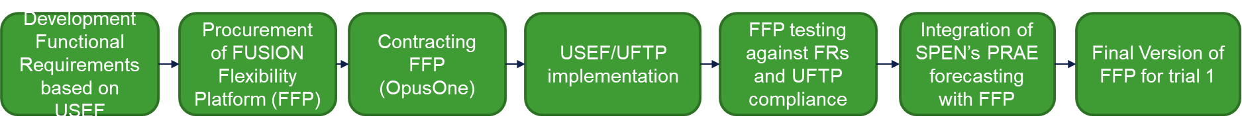

Figure 2: Procurement, development and testing map process of the FFP

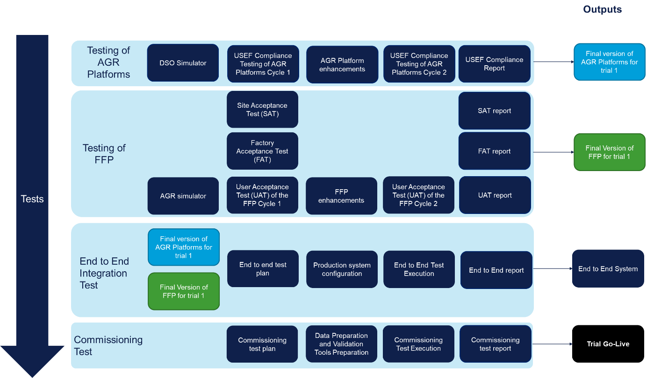

Figure 3: Testing processes to go-live

## Procurement and Contracting FFP

One of the key components for the trial set up is the FUSION Flexibility Platform (FFP) which is supporting the delivery of flexibility trials in East Fife area.

SP ENERGY NETWORKS, in collaboration with FUSION partners, developed a series of functional requirements that the FFP should meet, largely based on the USEF process descriptions, addressing both the DSO and CRO roles within USEF. In May 2020 SP ENERGY NETWORKS published the Platform Communication & Procurement Specification document (i.e. FFP) in order to invite technology solutions providers that could deliver the platform. [4]

The 52 functional requirements were classified in 5 groups:

1. General Functional Requirements (#4)
2. Contract Phase Functional Requirements (#9)
3. Plan Phase Functional Requirements (#6)
4. Validate Phase Functional Requirements (#14)
5. Operate Phase Functional Requirements (#6)
6. Settlement Phase Functional Requirements (#13)

The detailed functional requirements can be found in the Specification document.

Following SP ENERGY NETWORKS’s procurement process, Opus One Solutions was selected as the FFP solution provider.

## Procurement and Contracting Flexibility

The section describes the flexibility procurement process, the evaluation methodology and the development of the Flexibility Services Agreement with the selected aggregators.

### Flexibility procurement process

Project FUSION’s flexibility procurement process consisted of 6 steps:

**Promote and attract:** Project FUSION took a number of steps to promote FUSION flexibility procurement and attract flexible providers. The project team developed several informative documents which were published on SP ENERGY NETWORKS’s website, including:

* 1. the flexibility “process map”, which provided visibility and transparency to the interested parties of the timeline and the detailed activities of the procurement process.[5]
  2. The Flexibility Service Request (FSR) documents for St. Andrews and Leuchars, which articulated the services requirements for the trial in 2021 and was developed to ensure the service windows occurred during normal business hours. [6] [7]

Following the publication of the documents, SP ENERGY NETWORKS published the Invitation for Expression of Interest (EoI), which was followed by a dedicated webinar to explain the process and provide clarifications to interested parties. In addition, during this stage, SP ENERGY NETWORKS asked certain questions to ascertain the extent to which interested parties could comply with the requirements of USEF as well as some other pre-qualification elements.

**Prequal ‘viability’:** In the second phase, ‘prequal viability’, through the EoI, Project FUSION firstly identified whether interested parties were or were willing to become USEF compliant or which of the USEF functionalities should be developed. In case of non-USEF compliance, the interested parties could find another party to partner with so they could cover the missing functionalities. Provided that interested parties gave their permission to reveal their identity to other interested parties, SP ENERGY NETWORKS would introduce non-compliant parties to other parties that could cover those missing functional elements.

**Prosumer engagement:** Another step was to promote engagement between prosumers and the tenderers (flexibility service providers), especially in case that the interested party did not have any flexibility enabled in East-Fife area or they wished to enable more assets than the current ones. Project FUSION invited tendered parties to approach prosumers, engage with them and further analyse their assets and their capabilities. This step was informed by the outcome of project FUSION WP2, whereby the flexibility potential and the potential Prosumers of East-Fife were investigated. Ultimately, this exercise aimed at paring, to some extent and where possible, prosumers (end-users) with the aggregators.

**Bidding:** The bidding process was very similar to Business-As-Usual (BAU) processes. SP ENERGY NETWORKS issued an Invitation to Tender (ITT) and asked interested parties to provide information about their organisation, their flexible assets and their commercial offer. As part of the respond to the ITT, the tenderers were also asked to indicate their technical capabilities to be USEF compliant and ready for Phase 1 of the trial, as well as a high-level indicative implementation plan from award of the contract to operational stage. Alongside the ITT letter, project FUSION developed additional documents to accompany the ITT such as the Flexibility Services Agreement (FSA) template and the tender evaluation criteria.

**Commercial evaluation:** SP ENERGY NETWORKS performed the commercial evaluation which is described in more detail in section 3.2.2.

**Sign FSA:** The successful bidders signed a Flexibility Services Agreement with SP ENERGY NETWORKS. Section 3.2.3 provides more details on the development of the FSA.

### Evaluation methodology

Project FUSION developed a methodology to select the tenderers that offered the highest value to the project by maximising the learnings. This methodology allowed Project FUSION to select the combination of Aggregators and portfolios that offered the most value. This exercise was not straight forward due to the low number of Prosumers available in the area, therefore ensuring the presence of more than one aggregator and that portfolios of different aggregators were not overlapping was essential.

The assessment method considered the following elements to select the most valuable aggregator/portfolio combination for both congestion points:

* The total cost
* The unit cost (£/kWh) of the offered flexibility
* The average available power across all services
* The diversity score:
  + High: **Both** relatively diverse sectoral representation (considering residential, agricultural and C&I) **and** relatively diverse mix of technologies
  + Medium: **Either** relatively diverse sectoral representation (considering residential, agricultural and C&I) **or** relatively diverse mix of technologies
  + Low: **Neither** relatively diverse sectoral representation (considering residential, agricultural and C&I) n**or** relatively diverse mix of technologies

The portfolio/aggregator combination would go through the knock-out criteria, which was designed to ensure sufficient learning:

* The number of aggregators has to be higher than one for each congestion point, to ensure competition
* Total cost should not exceed the allocated budget
* The average offered power (combining all services) is at least what was requested in the FSR

If exactly one combination meets these criteria, this combination will be selected, and the selection process is ended.

If more than one combination meets all these criteria, then the following secondary criteria are applied

* Lowest unit price (90% weighting factor)
* Highest technology / customer segment diversity (10% weighting factor)

Finally, the winning combination is selected, and the selection process ends.

### Flexibility service agreement

The Flexibility Service Agreements (FSA) includes the full terms and conditions of the provision of flexibility services and define the responsibilities of and the interactions between the Aggregator and SP ENERGY NETWORKS. Project FUSION used ENA’s FSA template as the basis of the FUSION FSA and adjusted it, so that the FSA fits for purpose and is USEF compliant. Changes were performed in the section 3 of the FSA which describes the Scope of Flexibility Services, in section 5 which describes the monitoring and equipment requirement. The amendments done to the FSA were only the crucial ones to ensure USEF-compliancy, for instance, the DSO is not allowed to stop a flex order (since in USEF flex orders are binding.

The FSA template was published as part of the ITT process. The FSA was finalised through bilateral discussion between SP ENERGY NETWORKS and each of the successful aggregators.

## FUSION trial architecture and Implementation

### UFTP Implementation

#### Communication protocol (UFTP)

The USEF Communication Protocol, formally referred to as the USEF Flexibility Trading Protocol (UFTP), describes the interactions and communication exchange between Aggregators and DSOs to resolve grid constraints at distribution level. The UFTP covers all phases in the USEF Market Coordination Mechanism (contract, plan, validate, operate and settle) and is designed to be used as a stand-alone protocol for flexibility forecasting, offering, ordering and settlement processes.

The UFTP specifications describe:

* The detailed communication exchange between DSO, Aggregator and Common References Operator (CRO) as well as UFTP use cases descriptions derived from the MCM;
* The USEF message descriptions, defining the attributes contained in each Extensible Markup Language (XML) message; and
* The USEF message transport mechanism.

To complement the UFTP Specifications, the USEF Foundation has made available a GitHub page containing the UFTP XSD (XML Schema Definition) files.[8]

During the implementation of the UFTP (by Opus One, Engie and Orange Power) and during UFTP compliance testing, several issues have been revealed. These have been reported to the GOPACS organisation that is responsible for maintaining the UFTP protocol and will be resolved in the next version. Given their technical nature, these issues are not included in this report.

In addition to these issues, also several potential enhancements have been identified, these are reported as change requests to the GOPACS organisation. The main enhancements are listed below:

* Proposal how to implement the metering message (which is described by the document *USEF the Framework Explained*, but not yet implemented in UFTP);
* Inclusion of Service ID (or service type) in the flex request message, allowing the DSO to specify for which service flexibility is required.
* Consider whether a FlexOrder could contain just *some* Imbalance Settlement Period (ISP’s) for that day rather than *all* of them.

#### UFTP library

Within USEF, a UFTP library has been developed, to streamline and shorten the implementation of UFTP in any platform.

The UFTP message library consists of the combination of two parts:

1. an open-source Java software library that can be integrated in the aggregator’s own software; and
2. A wrapper around this library that offers an Application Program Interface (API) that enables the aggregator (or any other USEF role) to communicate to other USEF roles according to the UFTP messaging scheme.

This library is open-source and accessible to all aggregators to facilitate the UFTP implementation in their systems. Section 3.3.1.3 presents a high-level description of the UFTP implementation by aggregators, including whether they used the library and the benefits it brought them.

#### UFTP implementation by Aggregators

To implement UFTP in their systems Orange Power used Kanban at GitHub as coordination tool between Orange Power’s software developers and UFTP’s specifications. Orange Power developed their own coding to match UFTP specifications and tested its implementation through the use of the DSO simulator. Orange Power used the UFTP library as a reference, but not directly as their codebase.

Orange Power also used the DSO simulator (described in section 3.3.2.2) and they found it very useful as they could use it as a testing tool. They also indicated that using the DSO simulator saved testing time and facilitated early identification of potential issues.

Engie (represented by Gridimp) implemented the UFTP in a cloud hosted layer. The internal communications for dispatches and metering between their onsite appliance devices and their cloud remained unchanged. In practice this means that all DERs connected to their hub can now participate in any USEF contract.

For their implementation Engie used the UFTP library. Engie found the library beneficial because:

* It allowed them to start from a common agreed baseline implementation;
* It saved time; and
* After implementing the UFTP library, they could make the modifications that suited their needs.

Engie also used the DSO simulator (described in section 3.3.2.2) as a counterpart to test their own communication.

#### FUSION Flexibility Platform (FFP)

The FUSION Flexibility Platform was implemented by Opus One as the successful bidder in the procurement process described in section 3.1.

To execute the project, Opus One developed and deployed its software solution, GridOS® to serve as the FFP. The solution developed had to be USEF compliant. Since being awarded this project, Opus One, SP ENERGY NETWORKS, and DNV engaged in numerous technical workshops to facilitate delivery of design deliverables as per FUSION requirements. These workshops have focused on various topics including:

* USEF Compliance
* SP ENERGY NETWORKS System Integrations
* Market Coordination Mechanism (MCM) Stage Process Flows
* Network visualization
* User Flows and Experience
* Flexible service metering
* Long and Short-term load forecasting
* FUSION trial market services
* FFP testing strategy
* Aggregator engagement

Opus One developed three iterations of the Detailed Design Specification (DDS), following feedback from SP ENERGY NETWORKS and DNV. During software development, Opus One and SP ENERGY NETWORKS continued to engage in technical discussions to support the delivery of the project.

Opus One developed a tailor-made FUSION solution, identifying in collaboration with SP ENERGY NETWORKS and DNV all the flows by which each of the USEF roles are expected to interact. Four process flows were outlined, explaining how the components of the system would engage and interact to realise each of the MCM stages and how data transfers would facilitate this.

There are four key entities that comprise the FUSION solution, as visualized in Figure 4. These are:

1. Constraint Management Service Provider (CMSP)
2. Common Repository Operator (CRO) Module
3. Distribution System Operator (DSO) Module
4. SP ENERGY NETWORKS Systems

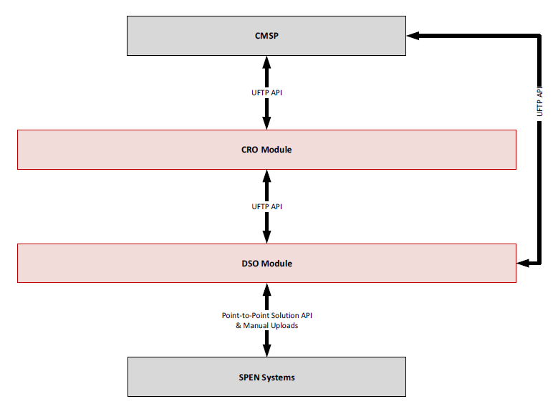

Figure 4: FUSION Solution Systems

In addition, through the technical workshops Opus One worked with SP ENERGY NETWORKS and DNV to determine the process flows associated with the FFP solution to meet the user flows and functional requirements. The solution architecture consisted of Architecture diagrams (detailing the internal components of the solution and their services), Integration (between SP ENERGY NETWORKS systems and the FFP solution), data models, and cybersecurity requirements. The figure below details the high-level solution service architecture.

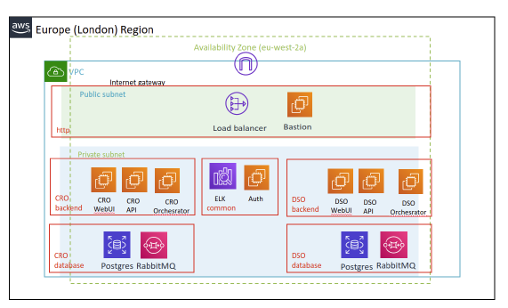

Figure 5: High-Level Service Architecture

### FUSION simulators

As shown in Figure 3, at the beginning of the chapter, a DSO and an Aggregator simulator were used in project FUSION. These simulators provided two benefits

* It allowed both Opus One and the aggregators a test environment, both to test their own systems and to validate whether their UFTP implementation was according to the specifications, without having to rely on the other party (aggregator / Opus One) that was developing in parallel
* It allowed a third party (in this case DNV) to test UFTP compliance, ensuring a smooth integration between the DSO platform (developed by Opus One) and the Aggregator platforms.

Both the AGR and DSO simulator have been developed by OrangeNXT and have been used by Dutch DSOs for USEF implementation in the Netherlands. These initial versions, however, did not include metering or settlement functionality, therefore OrangeNXT enhanced both simulators per request of FUSION. Also some technical enhancements were needed, e.g. the simulators did not sufficiently support parallel use by different users at the same time. Finally, several issues have been encountered when using the simulators, which have been resolved during the project and resulted in an enhancement to the tool. In addition to the ones already mentioned, these enhancements included:

* Multiple cycles for day-ahead trading
* User Interface improvements
* Settlement period adjustment (30 min instead of 15min)
* Configurable time zone
* Customizable CRO
* Automatic query and update CRO

#### Aggregator simulator

OrangeNXT created an environment for the use within FUSION. This was an as-is implementation and gave access to all the functionalities that were already developed and that are currently being used by Dutch DSOs. The endpoints of the AGR simulator were configured to support a connection to the FFP and the Fusion Common Reference Operator (CRO) environment. A settlement period of 30 minutes was also configured.

The “as is” version of the Aggregator simulator was further improved following discussions between OrangeNXT and SP ENERGY NETWORKS. The two main developments were the inclusion of the Metering and Settlement messages in the OrangeNXT’s AGR simulators. The inclusion of this functionality was based on the USEF Flexibility Trading Protocol Specifications.[9]

The following functionalities were included for the metering:

* Functionality to send Messages for Meter Data. OrangeNXT built the possibility in the user interface to generate and send these messages with dummy data for one or two metering point numbers per day. As standard input for these messages they used flex offers.
* Receiving and showing the content of the MeteringResponse from the DSO

The following functionalities were included for the Flex Settlement:

* Receiving and showing the content of the FlexSettlement message from the DSO
* Checking the FlexSettlement message from the DSO:
  + Syntax check
  + Check on PeriodEnd (PeriodeEnd>PeriodStart, PeriodeEnd<= current TimeStamp).
  + No other checks
* Send FlexSettlementResponse to DSO

#### DSO simulator

OrangeNXT delivered a DSO simulator (i.e. simulator of the FFP). Some of the functionalities of this simulator were already developed and FUSION got access to them for the purposes of testing. The DSO environment was further configured for FUSION.

The DSO simulator was further improved following discussions between OrangeNXT and SP ENERGY NETWORKS. The two main developments were the inclusion of the Metering and Settlement messages in the OrangeNXT’s DSO simulator. The inclusion of this functionality was based on the USEF Flex Trading Protocol Specifications.

The following functionalities were included for the metering:

* Receiving the metering message from the AGR
* Checking the metering message from the AGR:
  + Syntax check
  + check data completeness (lacking ISPs)
  + check meter value (condition >=0)
  + No check on validity of EAN or other checks
* Showing the content of the metering message
* Send MeteringResponse to AGR
* The metering message was not used for further validation or settlement. The flex settlement message was implemented as a separate flow with a newly generated message (described below).

The following functionalities were included for the Flex Settlement:

* Functionality in the user interface to generate and send flex settlement messages to the AGR with “dummy” data. Additionally and following feedback from project FUSION partners, OrangeNXT created the functionality for the user to manually change these daily messages before merging these into a flex settlement message.
* Send FlexSettlement message to AGR
* Receiving and showing the content of the FlexSettlementResponse message from the AGR

## Testing processes

Project FUSION developed a FUSION testing process before the trial went live. The tests that were performed are:

1. Factory Acceptance Test (FAT)
2. Site Acceptance Test (SAT)
3. Aggregator USEF compliancy test
4. User Acceptance Test (UAT)
5. End-to-end integration test
6. Commissioning test (CT)

### Factory Acceptance Test (FAT)

The goal of the FAT was for Opus One to demonstrate the functionality of the FFP in line with FUSION’s functional requirements and the Detailed Design Specifications (DDS). Figure 6 illustrates the interactions that were tested during FAT, and which systems were used for this test.

Opus One developed the FAT test script, whilst SP ENERGY NETWORKS provided the AGR simulator environment and received a report/analysis of the FAT outputs.

During the FAT test the following components were used:

* AGR simulator was used to check USEF-compliancy.
* Integration with the DSO forecast system (PRAE) was replaced by manually pre-filling the database with simulated forecast data.

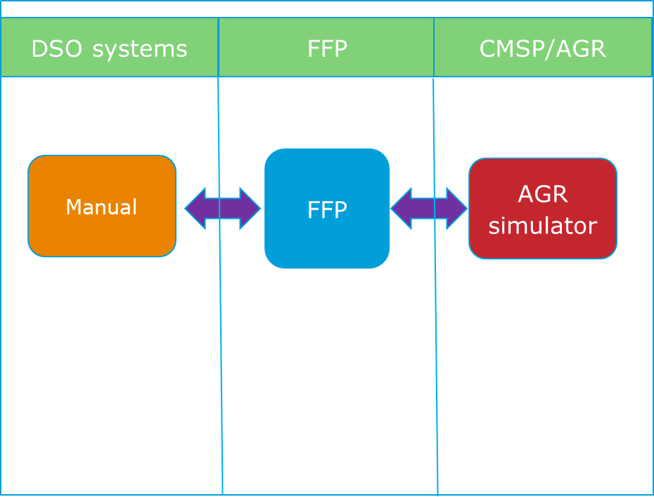

Figure 6: Components and testing interactions-FAT

### Site Acceptance Test (SAT)

The primary focus of SAT was to demonstrate the FFP functionality within the SP ENERGY NETWORKS environment and particularly the:

* Integration with SP ENERGY NETWORKS forecasting system, PRAE; and
* Demonstration of flow to a potential DSO user

Figure 7 illustrates the main components that participating in the SAT.

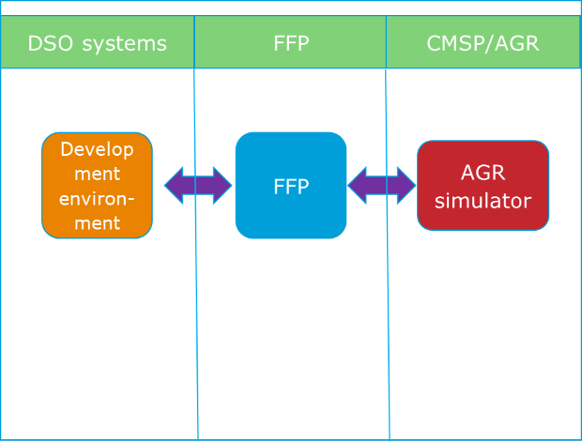

Figure 7: Components and testing interactions-SAT

The SAT plan was developed by Opus One. SP ENERGY NETWORKS witnessed the process and provided the operating DSO systems. In addition, SP ENERGY NETWORKS provided the AGR simulator environment (which was developed by OrangNXT).

SAT was conducted on QA environment over four session. Session 1 tested the DSO market stet-up and particularly the entities and PRAE integration. Session 2 completed the PRAE integration testing and tested the functionality of the FlexOptions of the DSO market setup. Session 3 provided DSO demonstration of the Validate Phase and session 4 provided DSO demonstration of the Operate Phase.

The SAT sessions identified a number of enhancements that were implemented by Opus One.

### Aggregator USEF compliance test

Both Aggregators participated in the USEF compliance test. The purpose of the test was to ensure USEF compliance for two reasons:

* To be able to demonstrate and validate the perceived benefits of the USEF framework, full compliance by all participants is required
* By adhering to the same standard for information exchange, seamless integration between the DSO (SP ENERGY NETWORKS) platform and Aggregator platforms can be achieved.

USEF compliance of an Aggregator can be characterised by the following elements:

* The processes of the Aggregator, which are relevant for flexibility trading (e.g. forecasting, trading, dispatch and settlement), should comply with the relevant USEF process descriptions. The USEF compliance was assessed against the *USEF Framework Explained Update 2021*,[10] particularly chapter 4.3. that describes the information flows for DSO constraint management.
* The Aggregator platform should interact with the DSO platform in compliance with the USEF protocol for flexibility trading (UFTP compliance test). The UFTP compliance was assessed against the requirement laid out in the documents *Project FUSION - Specification of communication protocols between market participants”**[11]* and “*USEF Flexibility Trading Protocol Specifications*”.9

The Aggregator USEF compliance test was developed by DNV and was conducted by DNV on behalf of SP ENERGY NETWORKS. The two main components that were used are:

1. The DSO simulator that was developed by OrangeNXT
2. The AGR platform, which was provided by each Aggregator and was tested for USEF compliancy
3. Interaction with DSO systems was less relevant, as the simulator did not interact with DSO systems.

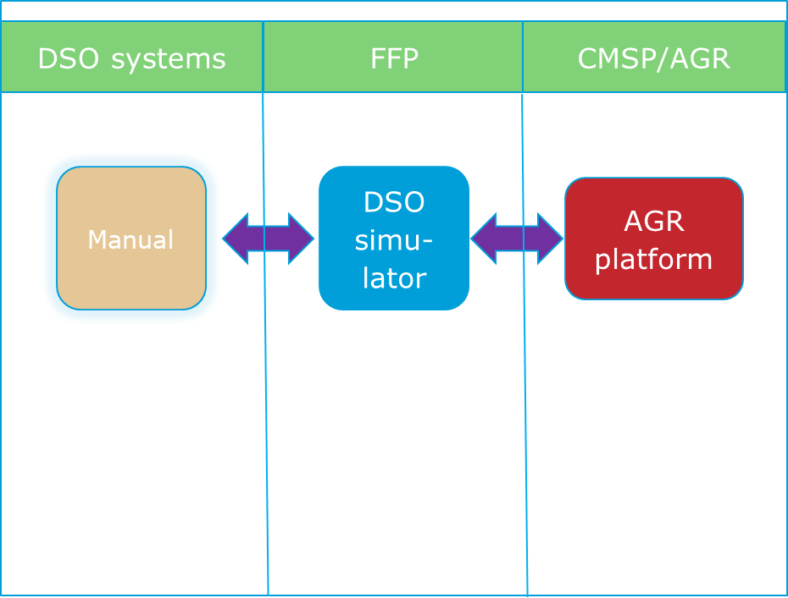

Figure 8: Components and testing interactions-Aggregator USEF compliance test

To assess the USEF processes compliancy, DNV conducted a 1-hour interview both with Engie (represented by Gridimp) and Orange Power in order to receive information with regard to:

* Background information (not part of the test)
* Contractual arrangements
* Energy management system/ monitoring / dispatching
* Forecasting
* Data management
* Power trading
* Settlement

To assess the UFTP compliance, DNV performed a test cycle with each aggregator. In case that further changes were required, the AGR performed the changes and DNV ran a second test cycle to ensure UFTP compliance.

### User Acceptance Test (UAT)

DNV performed a full User Acceptance Test of Release One of the Opus One Fusion Flexibility Trading Platform (FFP) in order to determine:

1. whether FFP meets the expectations which have been described in the document “*FUSION WP4: USEF Process Implementation Platform Communication & Procurement Specification”* ; this included UFTP compliance
2. Whether FFP is of high and sufficient quality to be used as the USEF Flexibility Trading Platform in the FUSION trial.

Certain tests could not be performed until Release 2 (for trial 2), when the functionality of FFP will be upgraded. These tests were omitted. These tests include exporting D-prognoses, sending FlexReservationUpdate messages and the Settlement phase.

Two test cycles were performed. Based on the test results of Cycle 1, DNV concluded that the FFP required additional changes prior to the start of the phase 1 live trial and in order for the FFP to be ready for integration with the Aggregators. Opus One conducted the required changes and DNV performed the second cycle in order to ensure that the FFP meets all the requirements prior to the live trial.

### End-to-end integration test

The End-to-end integration test precedes the commissioning test, and its purpose was for Opus One to demonstrate full integration of the FFP with SP ENERGY NETWORKS’s and Aggregator’s systems.

Opus One developed the end-to-end integration test plan and all parties and their components that will be used during trial (SP ENERGY NETWORKS, Opus One and Aggregators) took part of the testing process.

End to End (E2E) Integration Testing was completed over a few planning and testing sessions completed with SP ENERGY NETWORKS and aggregators Gridimp and Orange Power on the following dates:

* Tuesday, August 3rd , 2021 Testing
* Thursday, August 5th , 2021 Testing
* Monday, August 16th , 2021 Testing
* Tuesday, August 17th , 2021 Testing
* Wednesday, August 18th , 2021 Testing
* Thursday, August 19th , 2021 Testing
* Wednesday, August 25th , 2021 Planning
* Thursday August 26th, 2021 Planning

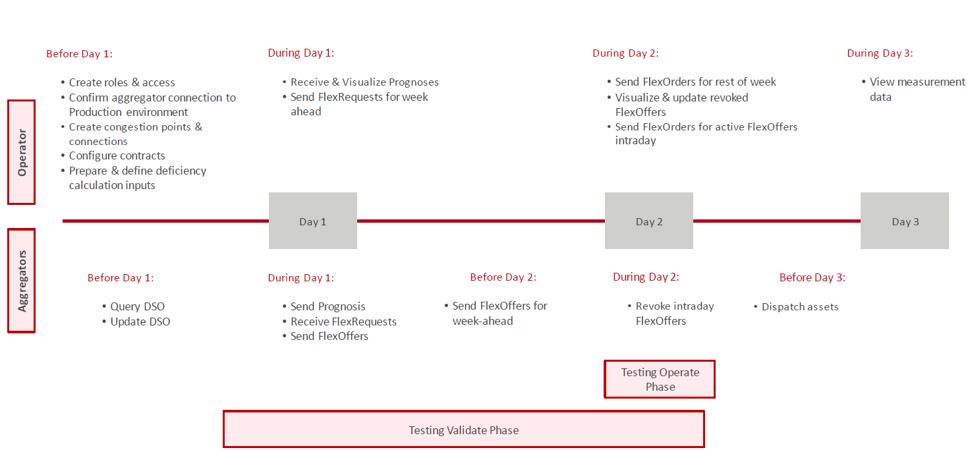

Figure 9: Structure and timeline of the end-to-end integration test (Planning Days 1, 2 and 3 were spread across more actual days due to resource requirements)

The outcomes of the test showed that all test cases were passed. There was a single hotfix deployed that corrected for a gap in design in Operate Phase XML communication between the DSO and aggregators. This was deployed on Wednesday, August 25th, and the Operate Phase was re-tested on Thursday, August 26th, and passed all test cases.

### Commissioning test

The commissioning test is the last step in the process prior to going live.

The objective of the commissioning test was to verify that the DSO systems, FUSION Flexibility Platform, Aggregators and DERs are fully interoperable and function as expected in real-life scenarios, according to the specifications in *FUSION WP4: USEF Process Implementation Platform Communication & Procurement Specification*4 and associated references.

Figure 10 illustrates the main components, steps, and interactions that took place in the commissioning test.

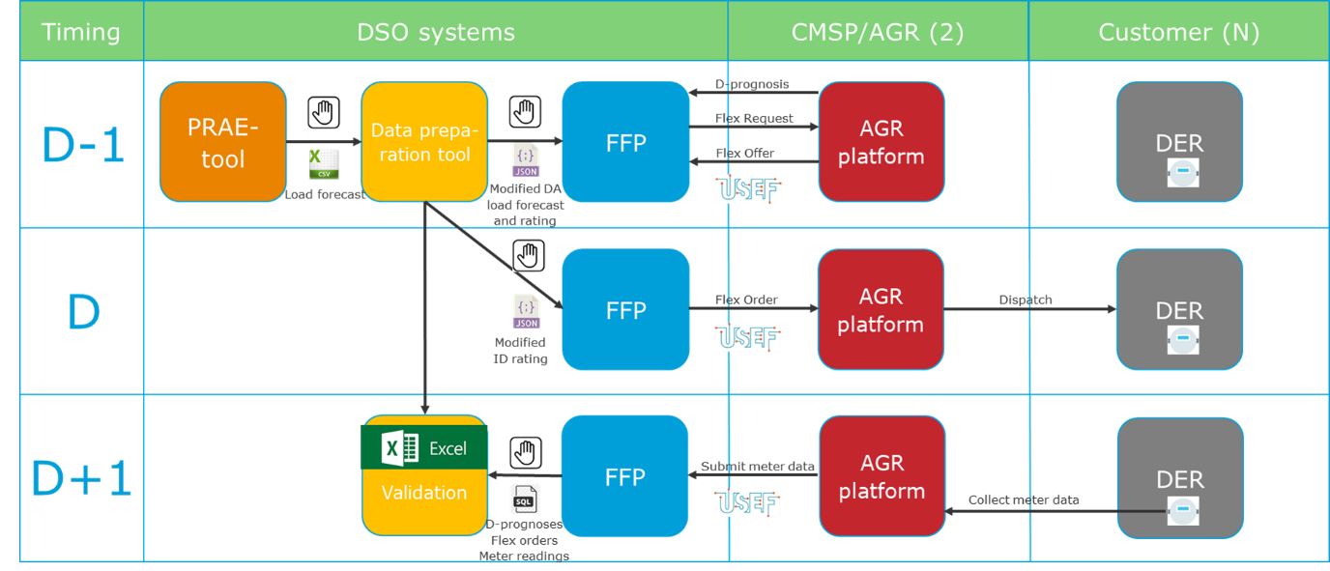

Figure 10: Steps, components and testing interactions of commissioning test

This test focuses on validating the interoperability in terms of functional behaviour, including validating that the end-result (solution of congestion) is as expected (in terms of both magnitude and timing). It is a final check which should ensure that the trial environment will perform as designed. Since FAT, SAT, UAT and End-to-End testing were already been performed, only certain elementswere tested.

In order to minimise the costs and impact on the end-user, each participating asset was only activated once, except when the commissioning test elements need to be repeated. Therefore, a maximum of two test scenarios has been run, one for each congestion point.

Testing was carried out by SP ENERGY NETWORKS and the Aggregators, supported by DNV. Only one blocking issue was found during testing, which was quickly fixed by OpusOne. Testing continued and completed without further issues. Based on these results, DNV concluded that the system is of sufficient standards to proceed to the field trial.

The following additional observations were made during testing:

* When the D-Prognoses are sent before the PRAE forecast is loaded, the profile visualisation is not updated to show the non-aggregator forecast. This does not impact the proper functioning of the flex procurement process.
* When the assets of an Aggregator mainly generate electricity, and are only used when flex is requested, then the D-Prognosis will normally be zero and therefore not visible in the profile visualisation.
* The D-Prognosis provided by Orange Power at both congestion points did not correspond closely to the metered data.

#### Supporting tools

Two tools were developed to support the commissioning test as well as the start of phase 1 of the trial. Those tools are:

* Data preparation tool: During the commissioning test and during phase 1 all congestion will be simulated, since there is not real congestion in the physical assets. The data preparation tool was developed to adjust real forecasting data and the maximum power profile of the selected substation to simulate the different test cases (section 3.5.1).
* Validation tool: Because the FFP (release 1) does not include the settlement capability, a number of SQL statements were developed to facilitate the validation of the flexibility delivery and thus, settlement.

## Operation

The trial went live on 9th September. Hence, the learnings and the experience with its operation is limited. The section provides an overview of the FUSION trial test cases and the schedule for simulating each test case in the trial. The test cases will be simulated as per the test cases schedule.

### Use cases and test cases

#### Use case – Secure DSO Constraint Management (pre-fault)

**Use case description:** There is a need to reduce the demand on a distribution network asset [immediately or at least within the hour] under certain system conditions and at certain times of day for a maximum duration to keep that asset within its operational capability. This could support the network to avoid fault conditions, during both planned and un-planned maintenance work or where a constraint is forecast, using a DSO triggered service.

The flexibility required can come from one of three actions that help to reduce demand at the MPAN; a reduction in demand, an increase in generation or discharging a battery.

**Test case 1.1 - Secure DSO Constraint Management (pre-fault) - Reserve + Order**

To reserve and order flexibility under the Secure DSO Constraint Management product, there are certain preconditions that the operator would observe during day-ahead (D-1) and intraday (D) operation:

* Day D-1: The forecast for day D at congestion point Y is below the maximum power profile and peak load occurs between 14:00 and 16:00 on a weekday. The forecast can have inaccuracies; therefore, the operator uses a lower adjusted maximum power profile to reflect inaccuracies (>3% lower) to consider a potential forecast underestimation. When applying the power profile reduction, the forecast exceeds the profile. This triggers the operator to send FlexRequest for day D
* Day D: The real-time updated intraday forecast shows that the load will be above the maximum power profile somewhere between 14:00 and 16:00. This triggers the operator to send a FlexOrder by selecting the FlexOffers that cover the foreseen deficiency.

**Test case 1.2 - Secure DSO Constraint Management (pre-fault) - Reserve + no Order**

To reserve flexibility under the Secure DSO Constraint Management product and to not order it during intraday, there are certain preconditions that the operator would observe during day-ahead (D-1) and intraday (D) operation:

* Day D-1: The forecast for day D at congestion point Y is below the maximum power profile and peak load occurs between 14:00 and 16:00 on a weekday. The forecast can have inaccuracies; therefore, the operator uses a lower adjusted maximum power profile to reflect inaccuracies (>3% lower) to consider a potential forecast underestimation. When applying the power profile reduction, the forecast exceeds the profile. This triggers the operator to send FlexRequest for day D
* Day D: The real-time updated intraday forecast shows that the load will be below the maximum power profile between 14:00 and 16:00. The operator does not send any FlexOrders.

**Test case 1.3 - Secure DSO Constraint Management (pre-fault) - Free bid + Order**

To request free bids and activate them under the Secure DSO Constraint Management product, there are certain preconditions that the operator would observe during day-ahead (D-1) and intraday (D) operation:

* Day D-1: The forecast for day D at congestion point Y is below the maximum power profile and peak load occurs outside the availability windows (i.e. weekdays at any time except 14:00 – 16:00 or weekend). The forecast can have inaccuracies; therefore, the operator uses a lower adjusted maximum power profile to reflect inaccuracies (>3% lower) to consider a potential forecast underestimation. When applying the power profile reduction, the forecast exceeds the profile. This triggers the operator to send FlexRequest for day D.
* Day D: The real-time updated intraday forecast shows that the load will be above the maximum power profile in the next 30 min coinciding with the period in which the FlexRequest was made. This triggers the operator to send a FlexOrder by selecting the FlexOffers that cover the foreseen deficiency.

**Test case 1.4 - Secure DSO Constraint Management (pre-fault) - Free bid + no Order**

To request free bids and not activate them under the Secure DSO Constraint Management product, there are certain preconditions that the operator would observe during day-ahead (D-1) and intraday (D) operation:

* Day D-1: The forecast for day D at congestion point Y is below the maximum power profile and peak load occurs outside the availability windows (i.e. weekdays at any time except 14:00 – 16:00 or weekend). The forecast can have inaccuracies; therefore, the operator uses a lower adjusted maximum power profile to reflect inaccuracies (>3% lower) to consider a potential forecast underestimation. When applying the power profile reduction, the forecast exceeds the profile. This triggers the operator to send FlexRequest for day D.
* Day D: The real-time updated intraday forecast shows that the load will be below the maximum power profile for the coming periods. The operator does not send any FlexOrders.

**Test case 1.5 - Secure DSO Constraint Management (pre-fault) - FlexReservationUpdate**

To send the Aggregators a FlexReservationUpdate to release them from their availability obligation at a certain day, under the Secure DSO Constraint Management product, there are certain preconditions that the operator would observe during day-ahead (D-1).

* Day D-1: The forecast for day D at congestion point Y is below the maximum power profile and peak load occurs between 14:00 and 16:00 on a weekday. The forecast can have inaccuracies; therefore, the operator uses a lower adjusted maximum power profile to reflect inaccuracies (>3% lower) to consider a potential forecast underestimation. When applying the power profile reduction, the forecast doesn’t exceed the profile. This triggers the operator to send a FlexReservationUpdate.

#### Use case – Dynamic DSO Constraint Management (post-fault)

**Use case description:** There is a need to reduce the demand on a distribution network asset immediately following a network fault, for a maximum duration to keep that asset within its operational capability. This service is unplanned but could be scheduled for times of high network risk.

The flexibility required can come from one of three actions that help to reduce demand at the substation; a reduction in demand, an increase in generation or discharging a battery.

**Test case 2.1 – Dynamic DSO Constraint Management (post-fault) - Reserve + Order**

To reserve and order flexibility under the Dynamic DSO Constraint Management product, there are certain preconditions that the operator would observe during day-ahead (D-1) and intraday (D) operation:

* Day D-1: The forecast for day D at congestion point Y is below the maximum power profile and peak load occurs between 14:00 and 16:00 on a weekday. The operator knows that there might be a fault occurring the following day in one of the assets, which might lower the maximum power profile (by >3%). The operator lowers the maximum power profile to simulate what would happen if the fault occurred. After lowering the profile, the forecast exceeds the maximum power profile showing a deficiency. This triggers the operator to send a FlexRequest for the following day.
* Day D: Between 14:00 and 16:00 a fault occurs (i.e. the maximum power profile drops) and the operator immediately send a FlexOrder to remediate the deficiency.

**Test case 2.2 - Dynamic DSO Constraint Management (post-fault) - Reserve + no Order**

To reserve flexibility under the Dynamic DSO Constraint Management product and to not order it during intraday, there are certain preconditions that the operator would observe during day-ahead (D-1) and intraday (D) operation:

* Day D-1: The forecast for day D at congestion point Y is below the maximum power profile and peak load occurs between 14:00 and 16:00 on a weekday. The operator knows that there might be a fault occurring the following day in one of the assets, which might lower the maximum power profile (by >3%). The operator lowers the maximum power profile to simulate what would happen if the fault occurred. After lowering the profile, the forecast exceeds the maximum power profile showing a deficiency. This triggers the operator to send a FlexRequest for the following day.
* Day D: A fault doesn’t occur, and the operator doesn’t send any FlexOrder.

**Test case 2.3 - Dynamic DSO Constraint Management (post-fault) - Free bid + Order**

To request free bids and activate them under the Dynamic DSO Constraint Management product, there are certain preconditions that the operator would observe during day-ahead (D-1) and intraday (D) operation:

* Day D-1: The forecast for day D at congestion point Y is below the maximum power profile and peak load occurs outside the availability windows (i.e. weekdays at any time except 14:00 – 16:00 or weekend). The operator knows that there might be a fault occurring the following day in one of the assets, which might lower the maximum power profile (by >3%). The operator lowers the maximum power profile to simulate what would happen if the fault occurred. After lowering the profile, the forecast exceeds the maximum power profile showing a deficiency. This triggers the operator to send a FlexRequest for the following day.
* Day D: A fault occurs (i.e. the maximum power profile drops) and the operator immediately send a FlexOrder to remediate the deficiency.

**Test case 2.4 - Secure DSO Constraint Management (pre-fault) - Free bid + no Order**

To request free bids and not activate them under the Dynamic DSO Constraint Management product, there are certain preconditions that the operator would observe during day-ahead (D-1) and intraday (D) operation:

* Day D-1: The forecast for day D at congestion point Y is below the maximum power profile and peak load occurs outside the availability windows (i.e. weekdays at any time except 14:00 – 16:00 or weekend). The operator knows that there might be a fault occurring the following day in one of the assets, which might lower the maximum power profile (by >3%). The operator lowers the maximum power profile to simulate what would happen if the fault occurred. After lowering the profile, the forecast exceeds the maximum power profile showing a deficiency. This triggers the operator to send a FlexRequest for the following day.
* Day D: A fault doesn’t occur, and the operator doesn’t send any FlexOrder.

**Test case 2.5 - Dynamic DSO Constraint Management (post-fault) - FlexReservationUpdate**

To send the Aggregators a FlexReservationUpdate to release them from their availability obligation at a certain day, under the Dynamic DSO Constraint Management product, there are certain preconditions that the operator would observe during day-ahead (D-1).

* Day D-1: The forecast for day D at congestion point Y is below the maximum power profile and peak load occurs between 14:00 and 16:00 on a weekday. The operator knows that there might be a fault occurring the following day in one of the assets, which might lower the maximum power profile (by >3%). The operator lowers the maximum power profile to simulate what would happen if the fault occurred. When applying the power profile reduction, the forecast doesn’t exceed the profile. This triggers the operator to send a FlexReservationUpdate.

#### Use case – Sustain Peak Management

**Use case description:** There is a need to reduce the demand on a distribution network asset to keep that asset within its normal operational capability. This could be as a result of a forecast capacity constraint on the asset at a particular time, e.g. to reduce the demand on a critical asset during winter tea-time peak, using a DSO planned service. This service supports the deferral or avoidance of conventional approaches to network reinforcement.

The flexibility required can come from one of three actions that help to reduce demand at the MPAN; a reduction in demand, an increase in generation or discharging a battery.

**Test case 3.1 – Sustain Peak Management - Reserve + Order**

To reserve and order flexibility under the Sustain Peak Management product, there are certain preconditions that the operator would observe during day-ahead (D-1):

* Day D-1: The forecast for day D at congestion point Y is above the maximum power profile on a weekday in a period between any of these timeslots 09:00-10:30, 11:00-13:00 and 15:00-17:00. This triggers the operator to send a FlexRequest. After receiving FlexOffers from Aggregators, the operator selects the FlexRequest(s) and send FlexOrder(s) to cover the foreseen deficiency.

**Test case 3.2 - Sustain Peak Management - Free bid + Order**

To request free bids and activate them under the Sustain Peak Management product, there are certain preconditions that the operator would observe during day-ahead (D-1) operation:

* Day D-1: The forecast for day D at congestion point Y is above the maximum power profile on a weekend or a weekday in a period outside these timeslots 09:00-10:30, 11:00-13:00 and 15:00-17:00. This triggers the operator to send a FlexRequest. After receiving FlexOffers from Aggregators, the operator selects the FlexRequest(s) and send FlexOrder(s) to cover the foreseen deficiency.

**Test case 3.3 - Sustain Peak Management - FlexReservationUpdate**

To send the Aggregators a FlexReservationUpdate to release them from their availability obligation at a certain day, under Sustain Peak Management product, there are certain preconditions that the operator would observe during day-ahead (D-1).

* Day D-1: The forecast for day D at congestion point Y is below the maximum power profile on a weekday in a period between any of these timeslots 09:00-10:30, 11:00-13:00 and 15:00-17:00. This triggers the operator to send a FlexReservationUpdate.

#### Test cases mapping against trial objectives

DNV mapped the test cases against the trial objectives in order to identify which test cases are more suitable for testing certain learning objectives and obtaining the required data. The mapping exercise indicated that most learning objectives are test-agnostic (i.e. not dependent on specific tests in order to come to useful conclusions). There are only two objectives that are test case specific:

1. The USEF Innovative element “Free Bids” can only be tested in test cases 1.3, 1.4, 2.3, 2.4 and 3.2
2. The USEF Innovative element “**Market Coordination Mechanism (MCM)**”: No other objective will be informed by test cases 1.5, 2.5 and 3.3 except for this one.

### Trial simulation schedule

#### Simulation schedule St. Andrews

The table below shows the test schedule for the St. Andrews congestion point for the first two months of phase 1 of the FUSION trial.

Table 5: Simulation schedule St. Andrews

|  |  |  |  |  |  |
| --- | --- | --- | --- | --- | --- |
| **Date** | **Use case** | **Test case** | **FlexRequest Start Time (hh:mm)** | **Duration (hh:mm)** | **Power (kW)** |
| 7-9-2021 | Secure | 1.1 | 14:00 | 01:00 | 400 |
| 8-9-2021 | Secure | 1.2 | 14:30 | 01:00 | 250 |
| 9-9-2021 | Secure | 1.1 | 15:00 | 00:30 | 500 |
| 10-9-2021 | Secure | 1.3 | 17:00 | 00:30 | 200 |
| 11-9-2021 |  |  |  |  |  |
| 12-9-2021 |  |  |  |  |  |
| 13-9-2021 |  |  |  |  |  |
| 14-9-2021 | Dynamic | 2.1 | 14:30 | 00:30 | 200 |
| 15-9-2021 | Dynamic | 2.2 | 14:00 | 00:30 | 300 |
| 16-9-2021 | Dynamic | 2.3 | 16:00 | 00:30 | 500 |
| 17-9-2021 | Dynamic | 2.4 | 16:00 | 00:30 | 400 |
| 18-9-2021 |  |  |  |  |  |
| 19-9-2021 |  |  |  |  |  |
| 20-9-2021 |  |  |  |  |  |
| 21-9-2021 | Sustain | 3.2 | 17:00 | 01:00 | 300 |
| 22-9-2021 | Sustain | 3.1 | 09:00 | 01:00 | 400 |
| 23-9-2021 | Sustain | 3.1 | 09:30 | 01:00 | 250 |
| 24-9-2021 | Sustain | 3.2 | 13:30 | 00:30 | 400 |
| 25-9-2021 |  |  |  |  |  |
| 26-9-2021 |  |  |  |  |  |
| 27-9-2021 |  |  |  |  |  |
| 28-9-2021 | Secure | 1.1 | 14:30 | 01:00 | 250 |
| 29-9-2021 | Secure | 1.1 | 14:00 | 00:30 | 300 |
| 30-9-2021 | Secure | 1.4 | 10:30 | 00:30 | 500 |
| 1-10-2021 | Secure | 1.1 | 15:00 | 00:30 | 400 |
| 2-10-2021 |  |  |  |  |  |
| 3-10-2021 |  |  |  |  |  |
| 4-10-2021 |  |  |  |  |  |
| 5-10-2021 | Dynamic | 2.3 | 13:30 | 00:30 | 500 |
| 6-10-2021 | Dynamic | 2.4 | 13:00 | 00:30 | 300 |
| 7-10-2021 | Dynamic | 2.1 | 14:30 | 01:00 | 250 |
| 8-10-2021 | Dynamic | 2.1 | 14:00 | 00:30 | 500 |
| 9-10-2021 |  |  |  |  |  |
| 10-10-2021 |  |  |  |  |  |
| 11-10-2021 |  |  |  |  |  |
| 12-10-2021 | Sustain | 3.1 | 09:30 | 00:30 | 400 |
| 13-10-2021 | Sustain | 3.1 | 09:00 | 01:00 | 250 |
| 14-10-2021 | Sustain | 3.1 | 16:00 | 01:00 | 300 |
| 15-10-2021 | Sustain | 3.2 | 13:00 | 01:00 | 150 |
| 16-10-2021 |  |  |  |  |  |
| 17-10-2021 |  |  |  |  |  |
| 18-10-2021 |  |  |  |  |  |
| 19-10-2021 | Secure | 1.1 | 15:00 | 00:30 | 500 |
| 20-10-2021 | Secure | 1.2 | 14:00 | 00:30 | 400 |
| 21-10-2021 | Secure | 1.1 | 15:00 | 01:00 | 250 |
| 22-10-2021 | Secure | 1.3 | 10:30 | 00:30 | 500 |
| 23-10-2021 |  |  |  |  |  |
| 24-10-2021 |  |  |  |  |  |
| 25-10-2021 |  |  |  |  |  |
| 26-10-2021 | Dynamic | 2.1 | 15:30 | 00:30 | 250 |
| 27-10-2021 | Dynamic | 2.1 | 14:00 | 00:30 | 400 |
| 28-10-2021 | Dynamic | 2.1 | 15:00 | 01:00 | 300 |
| 29-10-2021 | Dynamic | 2.1 | 15:30 | 00:30 | 500 |

#### Test schedule Leuchars

The table below shows the test schedule for the Leuchars congestion point for the first two months of phase 1 of the FUSION trial.

Table 6: Simulation schedule Leuchars

|  |  |  |  |  |  |
| --- | --- | --- | --- | --- | --- |
| **Date** | **Use case** | **Test case** | **FlexRequest Start Time (hh:mm)** | **Duration (hh:mm)** | **Power (kW)** |
| 1-9-2021 | Sustain | 3.1 | 09:30 | 00:30 | 250 |
| 2-9-2021 | Sustain | 3.1 | 11:00 | 01:00 | 100 |
| 3-9-2021 | Sustain | 3.2 | 13:30 | 00:30 | 150 |
| 4-9-2021 |  |  |  |  |  |
| 5-9-2021 |  |  |  |  |  |
| 6-9-2021 |  |  |  |  |  |
| 7-9-2021 | Secure | 1.2 | 14:30 | 01:00 | 100 |
| 8-9-2021 | Secure | 1.1 | 14:00 | 00:30 | 200 |
| 9-9-2021 | Secure | 1.3 | 17:00 | 00:30 | 150 |
| 10-9-2021 | Secure | 1.1 | 15:00 | 00:30 | 250 |
| 11-9-2021 |  |  |  |  |  |
| 12-9-2021 |  |  |  |  |  |
| 13-9-2021 |  |  |  |  |  |
| 14-9-2021 | Dynamic | 2.1 | 15:30 | 00:30 | 250 |
| 15-9-2021 | Dynamic | 2.1 | 14:30 | 00:30 | 250 |
| 16-9-2021 | Dynamic | 2.1 | 15:00 | 01:00 | 250 |
| 17-9-2021 | Dynamic | 2.4 | 16:00 | 00:30 | 250 |
| 18-9-2021 |  |  |  |  |  |
| 19-9-2021 |  |  |  |  |  |
| 20-9-2021 |  |  |  |  |  |
| 21-9-2021 | Sustain | 3.2 | 17:00 | 01:00 | 150 |
| 22-9-2021 | Sustain |  |  |  |  |
| 23-9-2021 | Sustain | 3.1 | 11:00 | 00:30 | 200 |
| 24-9-2021 | Sustain | 3.1 | 16:00 | 00:30 | 150 |
| 25-9-2021 |  |  |  |  |  |
| 26-9-2021 |  |  |  |  |  |
| 27-9-2021 |  |  |  |  |  |
| 28-9-2021 | Secure | 1.4 | 13:30 | 00:30 | 100 |
| 29-9-2021 | Secure | 1.1 | 14:30 | 00:30 | 100 |
| 30-9-2021 | Secure | 1.1 | 15:00 | 00:30 | 250 |
| 1-10-2021 | Secure | 1.1 | 14:30 | 01:00 | 200 |
| 2-10-2021 |  |  |  |  |  |
| 3-10-2021 |  |  |  |  |  |
| 4-10-2021 |  |  |  |  |  |
| 5-10-2021 | Dynamic | 2.1 | 14:30 | 00:30 | 200 |
| 6-10-2021 | Dynamic | 2.2 | 14:00 | 00:30 | 200 |
| 7-10-2021 | Dynamic | 2.3 | 16:00 | 00:30 | 200 |
| 8-10-2021 | Dynamic | 2.4 | 16:00 | 00:30 | 200 |
| 9-10-2021 |  |  |  |  |  |
| 10-10-2021 |  |  |  |  |  |
| 11-10-2021 |  |  |  |  |  |
| 12-10-2021 | Sustain | 3.1 | 09:00 | 01:00 | 100 |
| 13-10-2021 | Sustain | 3.1 | 11:30 | 00:30 | 150 |
| 14-10-2021 | Sustain |  |  |  |  |
| 15-10-2021 | Sustain | 3.1 | 10:00 | 00:30 | 100 |
| 16-10-2021 |  |  |  |  |  |
| 17-10-2021 |  |  |  |  |  |
| 18-10-2021 |  |  |  |  |  |
| 19-10-2021 | Secure | 1.3 | 17:00 | 00:30 | 250 |
| 20-10-2021 | Secure | 1.2 | 17:00 | 00:30 | 250 |
| 21-10-2021 | Secure | 1.1 | 15:30 | 00:30 | 200 |
| 22-10-2021 | Secure | 1.1 | 14:30 | 01:00 | 200 |
| 23-10-2021 |  |  |  |  |  |
| 24-10-2021 |  |  |  |  |  |
| 25-10-2021 |  |  |  |  |  |
| 26-10-2021 | Dynamic | 2.1 | 14:30 | 00:30 | 250 |
| 27-10-2021 | Dynamic | 2.1 | 15:00 | 00:30 | 200 |
| 28-10-2021 | Dynamic | 2.1 | 15:30 | 00:30 | 150 |
| 29-10-2021 | Dynamic | 2.2 | 15:30 | 00:30 | 150 |

### Validation and settlement

As described in section 3.4.6.1, the functionality for the validation and settlement process will be included in Release 2 of the FFP. Opus One included the following functionalities in Release 1 of the FFP:

* reception and validation of Meter messages
* storage of the received meter data.

In the interim and to facilitate the processes of phase 1 of the trial, validation of the flexibility delivery and settlement are performed manually. DNV developed a number of SQL scripts to assist the manual validation and settlement of delivered flexibility. These scripts extract data directly from the FFP database and can be used to compare aggregated meter data over several days, and also to calculate the delivered flex per day for each aggregator and congestion point. Exporting the extracted data to a spreadsheet allows a flex settlement report to be generated.

It is foreseen that SP ENERGY NETWORKS will use this method to create invoices on behalf of the Aggregators. Th invoices will then be approved by the Aggregators. The alternative method is that SP ENERGY NETWORKS sends the data to the Aggregators who will then create their one invoiced. Self-billing method is preferred, however, as it will streamline the settlement process.

# Learnings from the implementation

At the time of writing this report, the evaluation of the learnings objective is under development and therefore this section focuses on learnings from the implementation of the required processes, testing and tools for prior to the trial going live.

The learnings reflect:

* Learnings from the implementation of the UFTP and USEF processes by the Aggregators;
* Learnings from the developments of the FFP from OpusOne; and
* Learnings from FUSION partners

## Learnings from Aggregators

DNV asked the two Aggregators to provide their insights and learnings from the implementation of the UFTP and USEF process in order to be ready for the FUSION phase 1 trial.

DNV sent a questionnaire to the Aggregators with the following questions:

|  |  |
| --- | --- |
| **Question id** | **Question** |
| 1 | Based on previous experiences with integration efforts for DSO and ESO products, how would you compare the efforts of implementing UFTP? |
| 2 | To what extent would the adoption of UFTP by all GB DSOs remove barriers to participate in services for other DSOs? |
| 3 | What is the value of a test environment (the DSO stub) for future upgrades and new implementations? |
| 4 | In dialogues with DSOs, would you suggest or recommend the use of UFTP for DSO congestion management in GB? In continental Europe? |
| 5 | Can you provide an indication of your required effort to implement UFTP and be FUSION trial ready in man-days? Or |
| 6 | Would you classify the implementation of UFTP as low effort, medium effort, high effort? |
| 7 | Do you think that you had sufficient inputs and information to implement the UFTP  and be trial-ready? |
| 8 | Which were the main challenges during the implementation of the UFTP? |
| 9 | Which were the main challenges during the testing process of the UFTP? |
| 10 | What worked well during the implementation of the UFTP? |
| 11 | What would you have done different during the implementation of DSO platform? |

### Orange Power Learnings

Orange Power responded to DNV’s questions and the summary of their answers and learnings is provided below:

* The trading process of FUSION’s products and USEF’s trading are aligned with existing UK ESO and DSO products in terms of forecasting, metering and settlement. Orange Power had to deliver additional changes to their existing tool to meet USEF standards, such as the naming convention and the gate time.
* Orange Power highlighted the value of standardisation of the DSO procurement and flexibility market trading processes using UFTP or similar standards, as it would also help aggregators to standardise their tools and trading rules so that these align with all the DSO products.
* Orange Power highlighted the benefits of using a testing/ simulator environment. As per their experience, the lack of testing could lead to additional debugging issues during the end-to-end and commissioning testing, which would add extra time and effort during the commissioning period.
* Orange Power would recommend the use of UFTP for DSO congestion management in GB and in continental Europe. Indeed, in their response Orange Power indicated that they have discussed and made this recommendation to one of the European TSOs. With regard to the UFTP itself Orange Power identified several advantages of the UFTP document and guidance design:
  + the main specification is very clear with clear specifications into coding language, which according the Orange Power is not very common in other specification where the trading rules needs to be translated to coding by the developers themselves.
  + using the UFTP in other markets would reduce the effort of implementation and would make the process more practical on the basis that only one tool would be used and there would not be a need for operators/traders/developers to get trained or authorised to use different protocols in each market.
* With regard to the required effort to implement UFTP and USEF processes, Orange Power’s insights are also very useful. Based on their experience the largest amount of effort was required for getting familiar with and trained for the DSO energy trading, rather than for implementing the UFTP. The effort is medium in case that there is already a system in place which participates in other DSO or ESO markets, whilst the effort can be very high if prior work has not been carried out. Low effort would be required if the system developers have already had sufficient experience with energy trading.
* The main challenges that Orange Power encountered were linked to changes or wrong interpretation of the UFTP document.
* Finally, a recommendation raised by Orange Power for future aggregators is to start using the DSO stub earlier in the process, so that the coding cycles are delivered in shorter sprints, and then each small code sprint is tested and implemented before moving to the next coding sprint. This process would remove uncertainty when developed a long coding sprint, which is then more challenging to identify the error and change.

### Engie/Gridimp

Gridimp on behalf of Engie responded to DNV’s questions and the summary of their answers and learnings is provided below:

* Gridimp consider the implementation of the UFTP of medium effort. The UFTP implementation itself required around 60man-days and the support to platform changes (especially for automated bidded) required around 70 man-days for Gridimp. Compared to using the Flexible Power, Gridimp consider the UFTP implementation more complex, on the grounds of the additional functionalities of bidding and settlement.
* With regard to the value of the use of UFTP in GB, Gridimp suggested that the automation of bidding, dispatch and settlement are the key advantages of the UFTP. This automation will remove huge costs from both DSOs and aggregators at larger scale, which in turn would remove barriers to participation into the markets, especially for small flexibility providers (e.g. <100Kw). In addition
* Gridimp also provided feedback related to the implementation of the UFTP. They mentioned that the specification of UFTP and trial specific documents provided sufficient information, however they suggest that it would be more beneficial if the DNO simulation and the CRO stub were available earlier in the process. One of the main implementation challenges were was creating the right kind of internal representation of flex-availability for automated bidding and for representing the flow of a trade. The also encountered difficulties interpreting the specification with limited examples of the message flows. They identified one or two gaps uncovered in the specification, such as the interpretation of the encryption rules (double encryption) and sign of the power in the messages.
* Similar to Orange Power’s feedback, Gridimp consider the testing process essential and they recommend a test environment when developing the UFTP, such as a shared reference test environment. They also recommend the use of DSO simulators as early as possible in the process. Some of the challenges that they encountered during the testing processes are related to the validation rules of incoming messages .
* Finally, Gridimp provided the following recommendation in terms of UFTP:
  + Remove the ability to specify the duration for an ISP block in messages such as FlexRequest, instead simply include one entry for every ISP. This would make the implementation and validity checks easier and simpler.
  + Provide clearer information on switching between contracts in the messages. For example the FlexRequest could explicitly include the contract-id, which would make it clear how to interpret the contract.
  + Correction of types and missing fields in the XML schema.

## Learnings from OpusOne

OpusOne indicated the following learnings from the end-to-end integration testing which will be considered for further improvements to USEF and UFTP prior to phase 2 trial:

* Sending historical Imbalance Settlement Periods (ISPs) as part of an Operate phase FlexOrder does not actually provide much benefit from the operator perspective. As such ordering availability or deficiency for past time frames could be re-designed. This is a requirement based on the UFTP.
* Updated D-Prognoses are intended to capture any rebound effects in aggregator loading caused by responding to FlexOrders but these are very hard to capture in such short timeframes and to a granular extent, within an hour as mandated by the current implementation protocol. At present aggregators will not be accounting for rebound effects in Release 1.
* The formats of entity addresses for both congestion points and connections are not very user-friendly or easy to identify. A convention that may reference the names of congestion points and connections may be easier to utilize for both aggregators and operators
* At present AGRPortfolioUpdates are completed before AGRPortfolioQuery messages. It may be useful to facilitate the aggregators first getting access to all connections form the portfolio updates. At present, this has to be a manual exchange between the operator and aggregators
* The current UFTP and USEF structures do not allow for a hierarchical representation of congestion points, for example modelling congestion at multiplevoltage levels. SPEN is interested in forecasting and relieving congestion on both primary substation and low voltage levels. To this end, Opus has designed the FFP to allow this as a part of an added third release, but this functionality is limited by USEF. Some lessons learned from this include:
  + The lack of network-model based flexibility market operations means that current, voltage, and power flows across a network are not accounted for in procuring flexibility. A simpler calculation is made that compares transformer loading to its rating. Network-model based markets can allow for more comprehensive dispatch of assets that gives visibility beyond primary or secondary transformer levels
  + The congestion point-connection framework in USEF can be updated to allow for congestion points to be nested within one another to simulate logical network models and their powerflows at a high level

## Learnings from FUSION partners

### Optional UFTP features

USEF and UFTP consist of a set of mandatory requirements that the AGR and the DSO should implement. In addition, both include a set of optional features such as the inclusion of the rebound effect. Several of these optional features were not implemented for phase 1 due to a lack of explicit requirements towards the Aggregators for these items. As such, it is recommended that the tendering process of phase 2 should include explicit requirements for the implementation of certain optional features (which should be implemented by the participating aggregators), since they will contribute to the trial learning objectives that have been formulated. These features include:

* Rebound effect: The aggregator should specify in the flex offer, in case load (or generation) shifting is applied for delivery, when the rebound is expected to occur (limited to the same day, either before or after the activation).
* Delivery monitoring: The aggregator should ensure that it delivers the contracted flexibility, also if certain assets fail to deliver. In all cases the DSO should be notified if the Aggregator expects any under-delivery. This has at least three possible implications:
  + The Aggregator should have some redundancy in his portfolio, to ensure he can replace one asset by another if the first asset cannot deliver the required flexibility;
  + The Aggregator should monitor the delivery of all assets in real-time, and should take corrective measures if certain assets do not deliver;
  + The Aggregator should send an updated D-prognosis prior to the activation period, in case an Aggregator expects under-delivery that he cannot avoid, allowing the DSO to activate additional flexibility.

There are more optional features in UFTP, such as the support for partial activation. These have not been further elaborated here, as the need to test these features have not yet emerged (e.g. from the trial learning objectives).

# Evaluation of the learning objectives

The detailed evaluation methodology and plan for the learning objectives is under development and will be completed over September 2021. This section presents the high-level evaluation methodology of the USEF Innovative Elements (UIE), which is led by DNV. Each section consists of the success factors of the evaluation, the methodology itself and the required stakeholder engagement.

## D-Programmes

The key success factors of the evaluation of the D-programmes are:

1. Obtain a clear view on the DSO's information requirements and the ability of AGRs to provide this information, on different grid levels.
2. Provide an enhanced DSO forecast through the use of D-programmes. .

The assessment method of the D-programmes objective is described below:

* Based on the DSO information needs and the AGR capacity and willingness to provide information, a qualitative assessment can be drawn regarding the enhancement of DSO forecast of flexibility deployment. In particular:
  + Required information to enhance the DSO forecast
  + AGR requirements/conditions to provide information
  + Information that could be made available by AGR
  + Based on information availability, assess to what extent DSO needs may be covered and whether D-programmes can be used to enhance or produce forecasts at different grid levels
  + Additional information exchange that may be relevant for DSO forecasting activity that is not necessarily related to D-programmes, e.g. participation of assets in other flexibility services. This assessment may only be relevant if the flexibility is also traded on other markets
  + A comparison with historical baselines (see innovative element baselining) could be a metrics for the potential forecast quality improvement.

In order to obtain the required information which will be used for the qualitative and quantitative assessment, DNV will engage with SP ENERGY NETWORKS and Aggregators through workshops, bilateral discussions and the provision of questionnaires. The initial meetings and workshops are planned for September. Through these workshops DNV would clarify the data requirements for both SP ENERGY NETWORKS and Aggregators and discuss with Aggregators their capability and willingness to provide this information.

## Free Bids

The key success factors of the evaluation of the D-programmes are:

1. Obtain a clear view on how DSO products should be tailored to make optimal use of non-firm capacity (i.e. Capacity that the AGR cannot commit to offer long in advance), lowering the total utilisation costs.
2. Obtain a view on the potential savings when DSO products are optimised accordingly.

The assessment method of the Free Bids objective consists of 5 steps:

1. Identify assets that can provide firm and non-firm capacity and conduct exploratory data analysis to classify the assets based on:
   1. Type of asset
   2. Magnitude of the available non-firm capacity (scaled in time and place)
   3. Characteristics and potential availability: when and for how long these assets are available, under which conditions (e.g. ambient temperature-dependent), response time of these assets, how long in advance the assets need to be committed
   4. OPEX of these assets
   5. Availability cost of firm capacity assets
   6. Reliability of these assets based on activations within FUSION. Also portfolio aspects (that could increase reliability) should be considered.
2. Identify DSO needs for flexibility and conduct exploratory data analyses to classify the requests based on:
   1. Type of service requested (sustain, secure, dynamic)
   2. Frequency of requests
   3. Occurrence of requests in each settlement period/ day of the week/ week of the month/ season/ etc
   4. Magnitude of requests
3. Based on the previous steps, and on discussions with AGRs, identify what assets can provide specific DSO services based on response time, ramp up/down, acceptable on/off and increase/decrease frequency, availability duration.
4. Assess to what extent non-firm capacity may reduce DSO’s costs and system emissions. This could be done by
   1. Formulating an optimisation problem aiming at minimising costs and/or emissions, that should consider the DSO needs and the characteristic of the assets involved either as firm capacity or as non-firm capacity
   2. Comparing the total costs and emissions between different cases, where the type of assets is chosen based on an economic merit order list
   3. Examining the need to pay for availability (FlexOptions) if non-firm capacity is sufficiently available (e.g. when there is a strong correlation between DSO needs and the availability of non-form capacity).
   4. Quantifying the available (suitable) residential flexibility, relative to the industrial / commercial flexibility (based on BaU).
5. Based on the estimated size of DSO congestion markets in 2025-2030, and based on the outcome of previous steps, discuss with Aggregators the impact on their business model if non-firm capacity can participate in DSO products. Based on an estimate of flexible residential load, estimate the relative growth of number of Aggregators participating in DSO congestion management.

DNV will engage with SP ENERGY NETWORKS in order to clarify the data requirements and particularly with regard to information about flexibility requests and bid prices. DNV will also engage with Aggregators to obtain the required information, such information about their assets and the received remuneration. Free bids assessment is closely related to residential flexibility and therefore DNV will need to have visibility on the participating residential assets, and when these will become operational.

DNV will facilitate workshops, bilateral discussions and will also provide questionnaires to SP ENERGY NETWORKS and aggregators. The initial meetings and workshops are planned for September.

## Sub-metering arrangements

The success factor of this objective is to make clear recommendation on the use of sub-metering in DSO products at the end of the trial and the assessment. Particularly, the evaluation will provide quantitative outputs on the accuracy of metering data and baselines when sub-metering data is used and will reflect on the inclusivity of these arrangements with regard to various technologies and customer segments.

The assessment method of the sub-metering arrangements consists of the following steps:

* Identify the assets for which sub-metering is applied and their specific characteristics (e.g. ramp up/down, power profile and range)
* Identify how the AGR builds the baseline and which data they use to do so: depending on the chosen baseline method, a variety of data may be needed, e.g. historical consumption data, weather data, data of similar customers/asset
* Calculate baseline accuracy for each technology when using MPAN metering and when using submetering (using data of periods without DR events)
  + Assess differences among asset technologies and segment
  + Accuracy when MPAN or submetering can also be calculated using historical baselines, as the comparison with declarative baselines is performed in the learnings objective of the “Baseline design – nomination baseline”
* Calculate the magnitude of activated energy during DR events when using MPAN metering and when using submetering
* Estimate the differences in remuneration/costs for AGR and DSO when using MPAN metering and when using submetering. For example the assessment could start with the assumption that a 10% accuracy improvement reduces the required volume for the DSO by 10%. These assumptions will be discussed with SP ENERGY NETWORKS and discussed prior to implementation.
* CBA for aggregators based on costs of submetering infrastructure (hardware, software, data handling) vs MPAN metering
* Determine metering requirements (e.g. on accuracy)

A data validation process may also be required, depending on the quality of the available data. Data should be checked for:

* Data format
* Missing data points
* Zero values (i.e., true or error)
* Outliers / out of range (depending on asset to which submetering is applied)
* Trend of similar assets

Similar to the other objectives, DNV will engage with both SP ENERGY NETWORKS and aggregators. As a first step DNV will require visibility of the assets with MPAN and the assets with sub-metering. Per asset DNV will need to identify if, additionally, MPAN meter data or submeter data can be made available.

## Baseline design – nomination baseline

The key success factor of the evaluation of this objective is to deliver statistically sound results that will allow us to assess the performance of nomination baselines per asset type.

The evaluation method consists of the following items:

* Calculate accuracy of D-programmes per asset type
  + Compare actual measurements and D-programmes for non-event days
  + Compare accuracy of firstly submitted D-programme and D-programme updates. Since these updates are optional, the analysis will depend on the availability of such updates.
* Compare accuracy of D-programmes with accuracy of "standard" baselines (meter before meter after (MBMA)/historical):
  + Define ‘standard baseline’ parameters of historical baseline and MBMA: granularity, day selection, day exclusion, etc.
  + Produce ‘standard’ baselines with the use of historical metering data, depending on available data this could be MPAN metering or submetering data
  + Apply baseline assessment tool to compare accuracy, bias and variance of D-programmes and compare it to the rest of baselines. Either the DNV tool or TRANSITION tool can be applied, where both probably need some modification. Therefore a short analysis of the two tools is proposed to determine which is better fit-for-purpose.
* Evaluate D-programmes cost of implementation for DSO and AGR
* Assessment of DSO and AGR experience using D-programmes and how it compares with the use of other standard baselines
* Analysis of USEF processes applied
* Assessment of technology potential – determine if, and to what extent, the inclusivity of DSO products is augmented when using/allowing declarative baseline methodologies.
* Cost benefit analysis of D-programmes (i.e. nomination baselines)- If the inclusivity is augmented, then costs for DSO will decrease, flexibility will be a stronger alternative to grid reinforcements, and more carbon savings van be achieved.

For this objective DNV envisages engagement not only with the Aggregators and SP ENERGY NETWORKS, but also with the TRANSITION project through the TEF steering group. For example, as a first step, DNV will explore which tools should be used for the assessment considering the use of a baselining tool which has been developed through TRANSITION project, but also exploring and analysing the use of DNV's in-house baselining tool, so that DNV can assess to extend these tools can be used to calculate the accuracy for the historical baselines and the nomination baselines and identify future improvements to make the tool fit-for-FUSION evaluation.

In addition to this first step, DNV will further engage with SP ENERGY NETWORKS and aggregators in order to receive required information such as the D-programmes and metered data.

## Market Coordination Mechanism (MCM)

The key success factors of the evaluation of the MCM are:

1. Draw recommendations on DSO flexibility trading: timings, information exchange.
2. Draw recommendations on how to use services in relation to availability contracts

The assessment method of the MCM objective is described below:

* Based on the information provided by the DSO on current day-to-day operations and by the AGR on asset that could be involved in MCM, a qualitative assessment and comparative analysis between MCM and current flexibility process can be performed:
  + Additional required information exchange among involved parties
  + Information required by MCM that does not prove useful to DSO or AGR
  + Timings of each MCM phase and of information exchange among involved parties to fit the MCM into current DSO day-to-day operations
  + The extent to which more technologies/assets could provide flexibility depending on the MCM timings and requirements
  + The impact of flexibility trading on the rebound effect and how MCM could help managing it compared to current approach
  + Overall impact of the MCM in terms of system efficiency and reliability
  + Suitability of MCM for trading flexibility for different DSO congestion management products
* Based on the testing of different services, a dialogue with the DSO should provide clarity on
  + Are the ENA-defined services fit-for-purpose?
  + Will all different services be used, and under which circumstances?
  + Will services be used in parallel?
  + If so, can assets participate in different services at the same time?
  + Should FSPs and/or assets be contracted for specific services, or should they be contracted as flexibility to be used in different services, at the DSO’s discretion?
  + What is the impact of the aspects above on the standardised contract (FSA)?

In order to obtain the required information which will be used for the qualitative and quantitative assessment, DNV will engage with SP ENERGY NETWORKS and Aggregators through workshops, bilateral discussions and the provision of questionnaires. The initial meetings and workshops are planned for September. Through these workshops DNV would clarify the data requirements for both SP ENERGY NETWORKS and Aggregators and discuss with Aggregators their capability and willingness to provide this information.

## USEF Flexibility Trading Protocol (UFTP)

The key success factors of the evaluation of the UFTP are:

1. Recommendation about the use of UFTP for DSO congestion management in GB (in relation with the ENA products)
2. Issues and improvements are fed back to UFTP maintenance.

The assessment method of the UFTP objective is described below:

* Qualitative comparison between the AGR experience with other flexibility protocols and UFTP
  + Functionality
  + User experience
  + Effort required for implementation
  + Advantages/disadvantages
* Qualitative comparison between the DSO experience with other flexibility protocols and UFTP
  + Functionality
  + User experience
  + Effort required for implementation
  + Advantages/disadvantages
* Comparative analysis of the use of UFTP for one single flexibility product and for several flexibility products and changes associated to it (e.g. new attributes)
* Comparison with the data exchange within TRANSITION
* Creation of a backlog with improvements suggested by DSO and AGR.

In order to obtain the required information which will be used for the qualitative assessment, DNV will engage with SP ENERGY NETWORKS and Aggregators through workshops, bilateral discussions and the provision of questionnaires. The initial meetings and workshops are planned for September. Through these workshops DNV would clarify the data requirements for both SP ENERGY NETWORKS and Aggregators and discuss with Aggregators their capability and willingness to provide this information.

# Next steps

## Next steps for the phase 1 trial

This section sets out the next steps for the completion of the trial and future deliverables related to phase 1 of the trial:

1. Workshop with SP ENERGY NETWORKS and Aggregators. As it was explained in section 0 at least 1 workshop with SP ENERGY NETWORKS and 1 workshop with the Aggregators will take place in September to align on data requirements and the input for the qualitative assessment.
2. Project FUSION will continue the engagement with ENA and TEF, with a focus on the evaluation of the objectives and particularly the USEF innovative elements of baselining and sub-metering. This engagement will be ongoing over the course of phase 1 of the trial.
3. DNV and other project FUSION partners will proceed with the development of tools /reports required for the evaluation of the learnings objectives. The development of the tools / reports will commence in September.
4. The evaluation of the objectives and the CBA required continuous data collection from trial and data analysis, until the end of the trial.
5. The quantitative assessment of the objectives will commence with the workshops and the questionnaires that will be provided to SP ENERGY NETWORKS and the aggregators. It is expected that the quantitative assessment will be completely with the completion of the trial.
6. The qualitative assessment of the objectives will commence with the workshops and the questionnaires that will be provided to SP ENERGY NETWORKS and the aggregators. It is expected that the quantitative assessment will be completely with the completion of the trial.
7. Project FUSION will develop a full trial learnings report which will be completed in March 2022.
8. GOPACS (see section 1.2 for reference) may publish a new version of the UFTP specifications in the second half of 2021. In this case FUSION should consider whether it will deploy the new version in phase 2, and state this as a requirement for aggregators participating in phase 2.

## Phase 2 trial

Project FUSION’s key objectives for phase 2 are:

1. Apply the first USEF-compliant local flexibility market to alleviate real congestion in East Fife
2. Generate additional learnings to help to standardise the GB DSO flexibility market

### Alleviating real congestion in East Fife

Phase 1 of FUSION trial dispatches real time flexibility onto SP ENERGY NETWORKS’s network in response to simulated congestion only, at the voltage level of 33 kV.

In phase 2, project FUSION will dispatch real flexibility onto SP ENERGY NETWORKS’s network in response to real congestion at both 33 kV and 11 kV.

### Learnings objectives for phase 2

Project FUSION partners have already identified the learning objectives for phase 2. These objectives are summarised below. Please note that these objectives and the definition are subject to change and revision by project FUSION partners.

1. FSP Objective – Demand Side Flexibility potential: Explore the potential for localised demand-side flexibility utilisation to accelerate new demand connections to the network that otherwise would require traditional reinforcement.
2. FSP Objective – Efficient DNO network management: Gain an understanding of the potential use and value of flexibility within geographically local regions to further enhance efficient DNO network management.
3. FSP Objective – Business case of USEF-based flexibility market: Demonstrate the proof of concept, and evidence the business case, of commoditised flexibility (locally and for GB) through a USEF-based flexibility market.
4. SP ENERGY NETWORKS Objective – Coordination with the ESO: This objective will look into the coordination and communication requirements with the ESO
5. SP ENERGY NETWORKS Objective – Decision making algorithm: Understand SP ENERGY NETWORKS's requirements with regard to the decision-making algorithm and as a second step, define and design this algorithm, for implementation to FUSION. Compare it with BaU for SP ENERGY NETWORKS and help to inform SP ENERGY NETWORKS best practise with a view to publishing more widely to inform industry.
6. SP ENERGY NETWORKS Objective/UIE – DSO Data Transparency/ Common Reference Operator (CRO): The primary use of the common reference is to map congestion points against connections and assets. A dedicated role (CRO) has been introduced by USEF to operate the CR. Explore to what extend FUSION can deliver DSO data transparency through the use of the CRO
7. UIE – SP ENERGY NETWORKS interfaces, Flexibility Platform Interfaces: Operating a market platform to support flexibility trading has a large impact on a DSO. When trading processes and DSO products are further standardised, the market platform can also be further standardised, opening ways for third parties to provide these services.

Over Q1 2021 and prior to the start of the 2nd trial, project FUSION will:

* Review and refine the objectives based on learnings from trial 1
* Develop in detail the evaluation methodology for each objective
* Develop detailed planning for obtaining the required inputs for each objective
* Develop tool and processes for the quantitative and qualitative analysis of the learnings objectives for phase 2.

### Phase 2 trial set-up

Prior to the 2nd trial, a second release of the FFP platform will take place. The steps are similar to those followed for phase 1.

1. A second flexibility tender will be published. The FSR is expected to be published in September 2021 and will be sized to alleviate real congestion. The bidding window will remain open until December 2021.
2. Enhancement of the of FFP to include additional functionalities (such as validation and settlement). This step consists of the following activities which are in line with the processes that were used in phase 2.
   1. Factory acceptance test (FAT)
   2. Site acceptance test (SAT)
   3. Use Acceptance Test (UAT)
   4. Aggregator System development
   5. Aggregator USEF compliancy test
   6. End-to-end integration test
   7. Commissioning test

### Stakeholder engagement

Project FUSION will focus on extended stakeholder engagement in order to ensure sufficient levels of Distributed Energy Resources (DER) for phase 2. In addition, it is envisaged that project FUSION will seek to recruit additional residential flexible assets and invite tendered parties to approach residential prosumers, engage with them and further analyse their assets and their capabilities.

In addition, project FUSION will continue engagement and dialogue with GOPACS organisation (which maintains the UFTP protocol) to discuss changes suggested by project FUSION, including learnings from Aggregators and OpusOne.

About DNV

DNV is the independent expert in risk management and assurance, operating in more than 100 countries. Through its broad experience and deep expertise DNV advances safety and sustainable performance, sets industry benchmarks, and inspires and invents solutions.   
  
Whether assessing a new ship design, optimizing the performance of a wind farm, analyzing sensor data from a gas pipeline or certifying a food company’s supply chain, DNV enables its customers and their stakeholders to make critical decisions with confidence.   
  
Driven by its purpose, to safeguard life, property, and the environment, DNV helps tackle the challenges and global transformations facing its customers and the world today and is a trusted voice for many of the world’s most successful and forward-thinking companies.

1. FSR Leuchars: [FUSION_Flexibility_Services_Requisition_Leuchars_SP ENERGY NETWORKS.pdf (SP Energy Networksergynetworks.co.uk)](https://www.spenergynetworks.co.uk/userfiles/file/FUSION_Flexibility_Services_Requisition_Leuchars_SPEN.pdf)
2. FSR St. Andrews: [FUSION_Flexibility_Services_Requisition_St_Andrews_SP ENERGY NETWORKS.pdf (SP Energy Networksergynetworks.co.uk)](https://www.spenergynetworks.co.uk/userfiles/file/FUSION_Flexibility_Services_Requisition_St_Andrews_SPEN.pdf)
3. Flexibility Service Agreement (FSA) template: [Flexibility_Services_Agreement_Template.pdf (SP Energy Networksergynetworks.co.uk)](https://www.spenergynetworks.co.uk/userfiles/file/Flexibility_Services_Agreement_Template.pdf)
4. [WP4: USEF Process Implementation (SP Energy Networksergynetworks.co.uk)](https://www.spenergynetworks.co.uk/userfiles/file/D4.1_specification_of_communication_and_procurement_platform.pdf)
5. https://www.SP Energy Networksergynetworks.co.uk/userfiles/file/FUSION_process_map.pdf
6. https://www.SP Energy Networksergynetworks.co.uk/userfiles/file/FUSION_Flexibility_Services_Requisition_Leuchars_SP ENERGY NETWORKS.pdf
7. https://www.SP Energy Networksergynetworks.co.uk/userfiles/file/FUSION_Flexibility_Services_Requisition_St_Andrews_SP ENERGY NETWORKS.pdf
8. https://github.com/USEF-Foundation/UFTP
9. <https://www.usef.energy/app/uploads/2020/01/USEF-Flex-Trading-Protocol-Specifications-1.01.pdf>
10. <https://www.usef.energy/app/uploads/2021/05/USEF-The-Framework-Explained-update-2021.pdf>
11. [https://www.SP Energy Networksergynetworks.co.uk/userfiles/file/D4.2_specification_of_communication_protocols_between_market_participants.pdf](https://www.spenergynetworks.co.uk/userfiles/file/D4.2_specification_of_communication_protocols_between_market_participants.pdf)